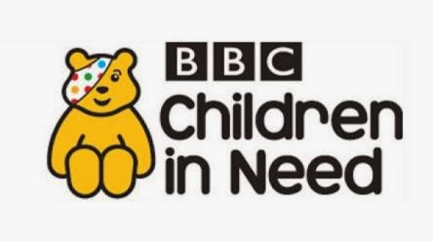
Dear Parents and Carers,

As you may already know, Monday 15th November 2021 is the start of this year’s BBC Children in Need Appeal Week. Longvernal are excited to be joining, with many others around the UK, the fundraising programme.
On Thursday 18th November 2021, after school, the Longvernal Community Leaders will be holding a cake and cookie sale. We are asking for donations, home-baked or shop-bought, to be sold to raise money for the charity. Any cake/cookie donations need to be handed to your child’s class teacher or the school office by Wednesday 17th November. Prices for cakes and cookies will start from 20p and will be no more than £1. We will only be accepting cash on this day.
On Friday 19th November 2021, The Longvernal Community Leaders are hosting a topsy turvy mufti day. They are asking that your child comes to school with their clothes on back to front, inside out, socks on their hands etc. – be creative! A donation page for the mufti day has already been set up on Parent Pay in readiness, we are asking that if your child wishes to take part, a small donation of £1 is made.
https://app.parentpay.com/ParentPayShop/Foc/Default.aspx?shopid=4203
Any questions, please ask your child’s teacher.

Many thanks,
Miss Collins and The Longvernal Community Leaders.

