COVID-19 - important information for parents and carers
Do not leave home if you or someone you live with has any of the following:
- a high temperature
- a new, continuous cough
- a loss of, or change to, your sense of smell or taste

Check the NHS website if you have symptoms
Definition of a household

- one person living alone
- a group of people (who may or may not be related) living at the same address and who share cooking facilities, bathrooms or toilets and/or living areas
- a support bubble

If you have COVID-19 symptoms or have received a positive test result

Stay at home and begin to self-isolate for 10 days from when your symptoms start. Arrange to have a test for COVID-19 if you have not already had one. The result of the test will determine how long you and your household must stay at home and self-isolate.

You and your household should stay at home while you are waiting for a home test kit or a test site appointment and the result.

A positive test result means you must complete a 10-day isolation period.

If you live in the same household as someone with COVID-19

Stay at home for 14 days. The 14-day period starts from the day the first person in your household developed symptoms or, if they do not have symptoms, from the day their test was taken.

If you do not have symptoms of COVID-19 yourself, you do not need a test. Only arrange a test if you develop COVID-19 symptoms.

If you live with other people, it can be confusing knowing what to do if more than one of you get COVID-19 symptoms. This simple illustration below explains how long members of the same household need to self-isolate for, if someone in the household develops COVID-19 symptoms and other people subsequently go on to also develop symptoms or not.

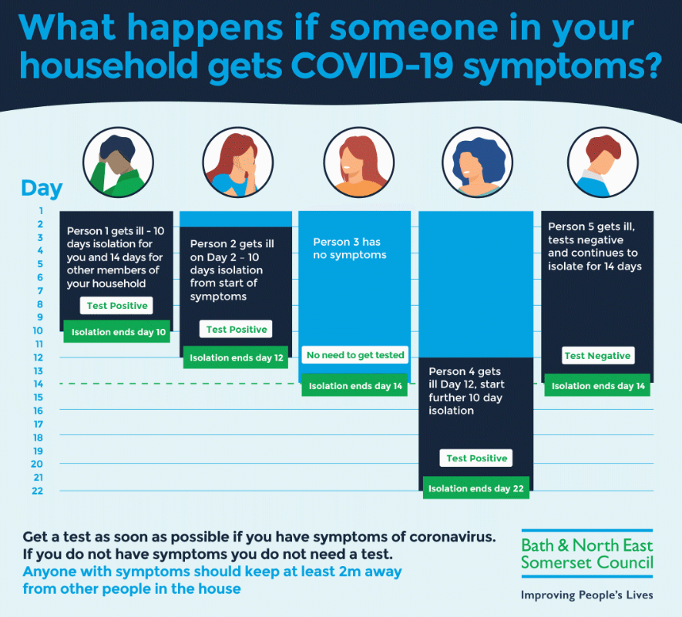

Financial Support

Information on financial help to self-isolate can be found on our website here;

https://beta.bathnes.gov.uk/coronavirus-covid-19-latest-information-and-advice/apply-test-and-trace-support-payment

