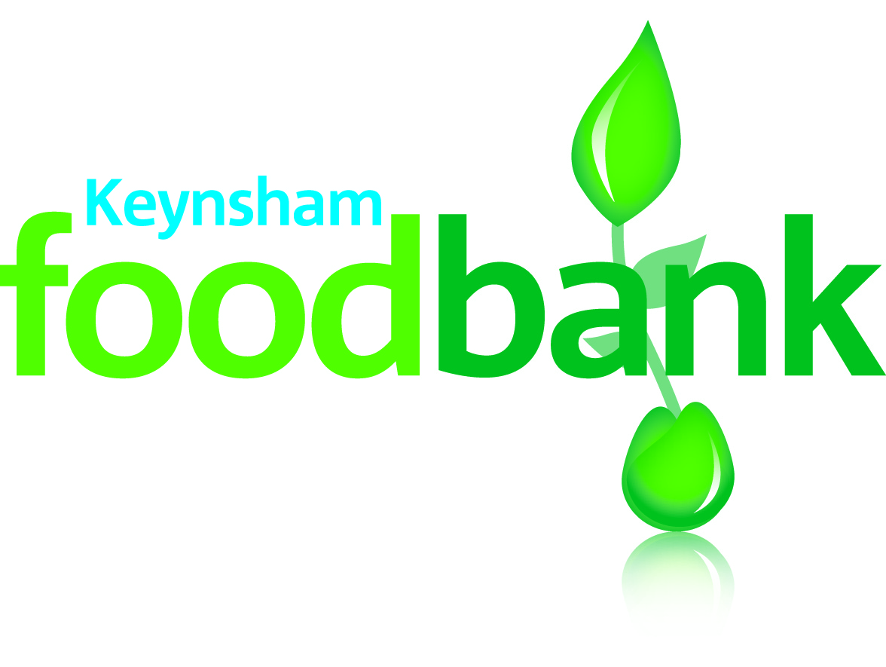

KEYNSHAM FOODBANK
IMPORTANT

Issued 20th April, 2020

NEW HOME DELIVERY AND VOUCHER ISSUE GUIDANCE FOR AGENCIES AND SCHOOLS REFERRING TO KEYNSHAM FOODBANK

As from Monday 27th April we will be operating a delivery only system. Currently Dial A Ride are providing deliveries where required and have kindly offered to take on a full delivery service on our behalf.

As so many more people are using our service we ask that you are particularly diligent in only referring those individuals and families who are most in need and do not have the financial resources to buy food. As you are aware our Foodbank is for those in genuine financial distress resulting in a food crisis and it is to those people we offer our support, many of whom have never used a Foodbank before.

For those people who are self isolating but have funds to buy food the following help lines can provide advice and guidance, e.g. volunteers to collect shopping:-
- Keynsham - Covid 19 Help Line Keynsham Community Response Team on 0753 407 1466 Open 7 days a week, 9am – 9pm
- Saltford – Covid 19 Help Line on 01225 632216 Open 7 days a week, 9am to 5pm
- Somerset Third Sector Group (SG3) on 0300 247 0050 Open 7 days a week, 9am – 5pm
The welfare and the benefit system also have supermarket vouchers for those people in need.

DELIVERIES

We will be delivering on a Monday, Thursday and Friday and ask that all requests for food are forwarded to me by 10 am on the day of delivery. Deliveries will be made during the afternoon of the delivery day.

NB. If you do receive a request for urgent emergency food on a day outside the delivery days please email me and I will endeavour to help.

‘E’ VOUCHERS’

Currently we are not set up for the e-voucher system but are in the process of doing so. I will contact you when we can offer the e-voucher system.

‘VIRTUAL VOUCHERS’

To protect clients and workers Foodbank vouchers will not be issued. All requests from the 27th April, 2020 will be via a ‘virtual voucher’.
To refer a client or family please email me on my secure email:- lesley@keynsham.foodbank.org.uk with the following details as requested on a Foodbank voucher. I understand that many of you are working from home and may not have access to a Foodbank voucher therefore I have given below the details required.

- Client first and last name
- Client Address and postcode
- Client contact, if agreed by the client
- Year of birth
- Number of adults in the household: 17-24 yrs of age/25-65 yrs of age/65yrs plus
- Number of children in the household: 0-4yrs of age/5-11yrs of age/12-16yrs of age,
- Main crisis, e.g. low income, benefit delay, debt
- Secondary crisis if applicable, e.g. homeless, domestic abuse

The request will be processed and the delivery made to the client or family. As stated above, requests must be emailed to me by 10 am on the day of the delivery.

The ‘virtual voucher’ system has already been working well and will continue until life returns to something approaching ‘normal’ or as an agency you are signed up for e-vouchers. If you have any queries or questions regarding the above please don’t hesitate to email me.

Do take care of yourself and your families.

Lesley Jones
Keynsham Foodbank Professionals’ Link Person and Designated Safeguarding Lead.

Lesley@keynsham.foodbank.org.uk

Registered Charity No: 1159856

