Emotion Coaching

A parent/carers weekly bite size guide

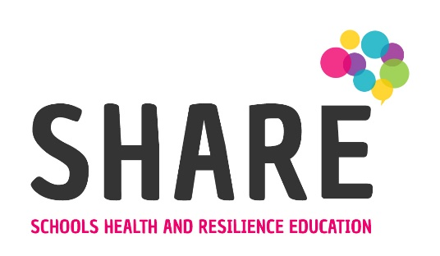
Do you feel any of these things?
My child doesn’t listen to me.
I don’t know what more I can do.
We used to be so close
My child doesn’t understand me

I don’t understand my child
I don’t know my child anymore
I have tried everything and nothing works

I am failing as a parent
Everything is hard work

I don’t enjoy spending time with my child
My child has no respect for me or their siblings

…then emotion coaching may be worth a try.
What is emotion coaching?

- Emotion Coaching is a way of supporting yourself, young people and adults who are struggling to regulate their behaviour.

- It enables us to potentially diffuse and de-escalate situations where people become upset, angry or aggressive.

- When we emotion coach we consider what the feelings, needs and emotions are behind the behaviour.

- Whilst the research is grounded in parenting the principle holds true more broadly for any interaction.
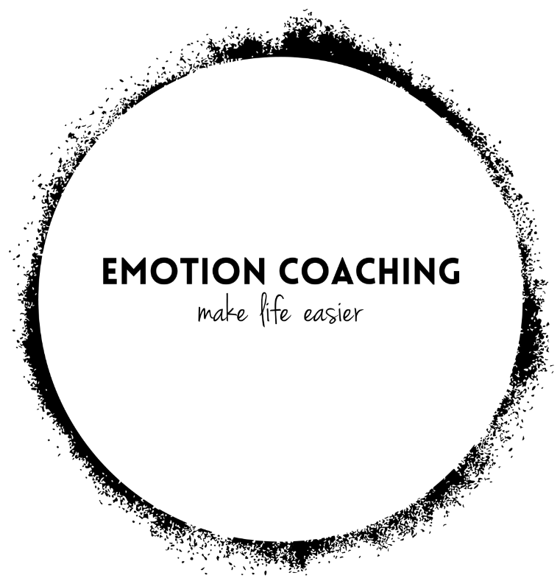

Where does emotion coaching come from?
John Gottman is an American Psychologist who has developed research on emotional intelligence, using a 5-step method that aims to build emotional intelligence and create positive, long lasting effects for children.

When can we emotion coach?
- 30-40% of the time.
- In moments of difficult emotion.
- As a communication tool.

Why emotion coach?
- Strategy to deal with life’s ups and downs.
- Accepting all emotions as normal.
- Emotion Coaching uses moments of heightened emotion and resulting behaviour to guide and teach the young person about more effective responses.
- Through empathetic engagement, the child's emotional state is verbally acknowledged and validated, promoting a sense of security and feeling 'felt'. This activates changes in the child's neurological system and allows the child to calm down, physiologically and psychologically.
- A calmer young person, a calmer adult and a calmer household.
- More resilient young people and adults.

