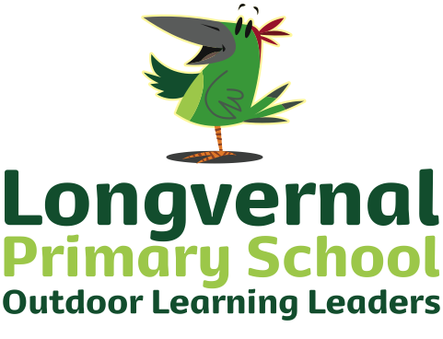
Clapton Road

Midsomer Norton

Radstock BA3 2LP

Telephone: 01761 412777

Fax: 01761 419883
Email: office@longvernalschool.com
Website: www.longvernal.com

“part of the Midsomer Norton Schools Partnership" Headteacher: Karen Bazeley
22nd November 2021

Dear Parents and Carers

You will no doubt be aware that Covid is currently very high in the area, in addition to many seasonal illnesses. I am writing to you about the impact this is having on Longvernal currently and our plans moving forwards to try and keep everybody in our community as safe as possible.

We are currently short of several staff. We will do our absolute utmost to stay fully open and avoid having to cancel any pre-planned day trips this term. However, it may be that your child tells you that they have been taught by a different teacher or has been supported by different Learning Support Assistants or Bath Spa trainee teachers than usual. It may be that some individual or small group interventions are affected if we do not have the staff to deliver these temporarily. Please bear with us; it is a forever changing situation. In the event that your child is currently isolating, there is emergency contingency work available for each class. Please be aware however that as the school is open (and short staffed) we cannot provide the level of interactive remote learning with the support that was possible during school closure last year. EYFS and KS1 use SeeSaw as their platform and KS2 use Google Classrooms. We will try to continue to change reading books and hear children read as usual but again please be patient and understanding.

It is with a heavy heart and after much deliberation and conversations with all involved that I have made the following decisions:
- Nursery and EYFS/KS1 nativity plays will be filmed rather than a live audience. I appreciate that this is really disappointing but we cannot safely sit such high numbers in the hall.
- Christmas Dinner will sadly be for children only, no family members. Dinner for the children will be on Wednesday 15th December. Any payments will be reimbursed but please bear with us as this will take time.
- There will be no carol service at the church this year, again owing to high numbers gathering.
The priority has to be trying to keep school fully open, keeping Covid case numbers down and safeguarding Christmas for everybody.

Thank you for your understanding. Any questions, please contact the school direct.

Kind regards

Karen Bazeley

