**Longvernal Primary School**

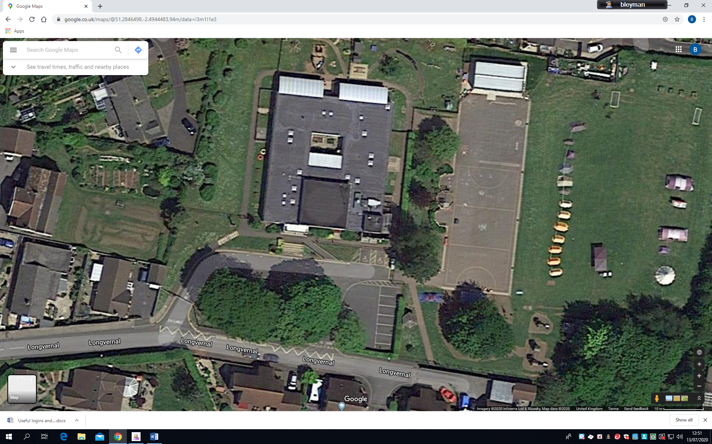

CAR DROP OFF ZONE

**Autumn Term 1**

**2020/2021**

**Norton Hill Primary Reception Zone**

ALLEY GATE

BOTTOM GATE

TOP GATE

WOODPECKER GATE

**Longvernal Reception Zone**

**Nursery Zone**