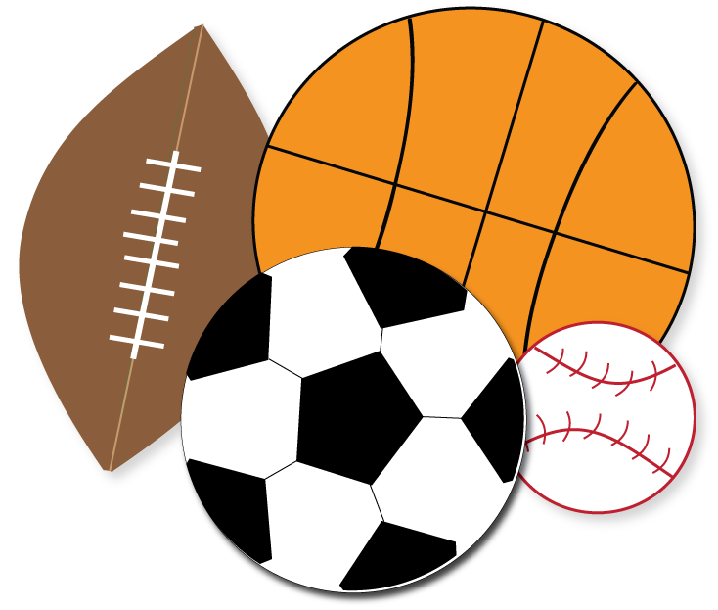

| **English**  In Writing, we will be writing free verse poetry and a narrative based on *The Bear and the Piano*. In Handwriting, the children will be focusing on primary consonants and vowels with their respective capital letters (a, c, e, i, m, n, o, r). Guided Reading will focus on a mixture of narratives, nonfiction texts and poems. In SPaG, we will be learning about sequencing sentences, finger spaces, capital letters, full stops, question marks, exclamation marks, the conjunction *and*, proper nouns and plural nouns.  **Phonics sounds**: special friends recap, ay, ee, igh, ow, oo, *oo*, ar, or, air, ir, ou, oy |  | **Important Dates**   * **2nd October**: Poetry Day * **7th/8th October**: Parents’ Evenings * **10th October**: Hello Yellow Day * **16th October**: Harvest Show and Share (2pm) * **23rd October**: Last day of term * **24th October**: INSET day |  | **Maths**  This term, Year 1 will be learning about place value within 10 and addition and subtraction within 10. Year 2 will be applying last year’s learning to place value and addition and subtraction with greater numbers. Year 2 will also begin working on their times tables, starting with their 2 times table! |  | **D.T.**  This term, the children will be learning all about food and nutrition. They will explore the food groups through the Eatwell plate, applying this to making healthy meals, snacks and drinks. They will also be making a seasonal meal - pumpkin soup! | |
| --- | --- | --- | --- | --- | --- | --- | --- |
|  |  |  |  |  |  |  |
| **Music**  In Music, the children will be learning about and applying the following terms: pulse, rhythm, pitch, dynamics, tempo, melody, chorus, verse, solo, unison, vocal percussion and body percussion. |  | **Science**  We are beginning our Animals Including Humans topic this term. We will learn about cold-blooded and warm-blooded animals, carnivores, herbivores, omnivores and the human body! |  | **Nightingale Class**  **Term 1**  **2025 - 2026** |  | **RE**  This term, we will be learning about what Christians believe about love. We will explore the term agape, see how Christians prioritise forgiveness, friendship, mercy and sharing. We will also learn about the significance of the Lord’s Prayer. | |
|  |  |  |  |  |  |  |
| **History**  Our topic in History is significant people. We will learn about Florence Nightingale and Mary Seacole, looking at their work in the Crimean War and influences on modern nursing. |  | **PE**  This term, the children will be developing their fundamental fine motor skills alongside exploring various invasion games such as football and netball! |  | **Computing**  This term, the children will be looking into IT in the world around us. They will also be creating media through digital painting! They will also learn to log on and use a mouse and trackpad. |  | **PSHE**  Our focus this term is Being Me in My World. We will explore hopes and fears, rights and responsibilities, rewards and consequences and learning charters. | |