Dear Parents and Carers,
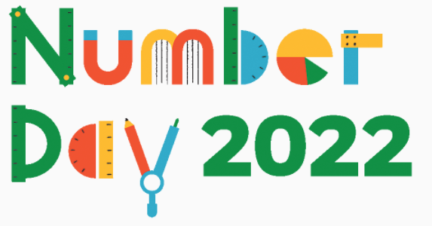
On Friday 4th February 2022, the Longvernal Community Leaders will be hosting NSPCC Number Day!
To celebrate everything maths and number, Longvernal will be participating in Dress Up for Digits, where we are asking that your child comes to school wearing as many numbers as they can! This may be wearing something that has numbers on it or getting creative, adding your own numbers to something you already own!
If your child wishes to participate in NSPCC’s Dress Up for Digits, we ask that they donate £1 to the charity. Money will be collected by the Community Leaders on Friday 4th February.

Any questions, please ask your child’s teacher.

Kind regards,
Miss Collins and The Longvernal Community Leaders.

