Clapton Road

Midsomer Norton

Radstock BA3 2LP

Telephone: 01761 412777

Fax: 01761 419883
Email: office@longvernalschool.com
Website: www.longvernal.com

“part of the Midsomer Norton Schools Partnership" Headteacher: Karen Bazeley

25th January 2021

Dear Parents/Carers

Craft Activity
The PTFA has put together a craft activity for your child to enjoy. We will be providing every child with a craft pack to create your own Window Wanderland.

The packs will be available to collect from a table located just outside the main school entrance (by the vehicle drop off point) on Friday 29th January 2021 at the following times;
9:30am – 10:30am
3:45pm – 4:30pm
If your child is attending school, the pack will be sent home with them on Friday 29th January 2020.

Please see below instructions to create your own Window Wanderland, we look forward to seeing photos of your creations.

Instructions:

- Measure the window
- Plan your design, don't think too big, less it more
- Use the black card for your design, could be animals, could be trees, could cartoon characters, could be sport, use your imagination & have fun
- Then use the cellophane sheets for the colour of your display
- Have fun & get excited for your window night time display

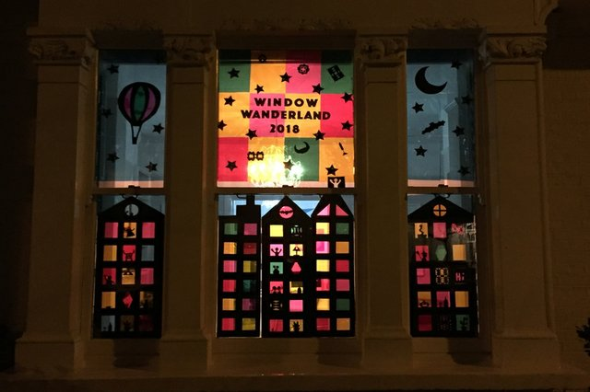

Yours sincerely

Karen Bazeley
Head Teacher & The PTFA

