Phone App’s:
There is a current list of available phone app’s which may be a helpful resource for our Children, Young People or Parents. While we can not be recommend app’s outside of NHS.uk, however we can a share that, there is a range of app for a clients to browse and consider useful to look at.
www.nhs.uk/apps-library/
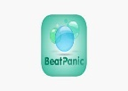
Beat Panic
App store
Purchase .99
Who is it suitable for? Anyone who experiences panic attacks or anxiety. It can be used wherever you happen to be when a panic attack or anxiety occurs – whether you're at home or out and about.
How does it work?
The Beat Panic app uses a series of soothing coloured flashcards with messages designed to help you overcome a panic attack in a calm, gentle manner.
Beat Panic aims to help you:
Focus on something else instead of the panic or anxiety
Slow your breathing, reduce your heart rate and release the tension
Get perspective on any worrying thoughts and remind you what is really happening
Overcome the urge to flee

BlueIce
Categories: Mental health, Child health
Free

Who is it suitable for?
Anyone who experiences panic attacks or anxiety. It can be used wherever you happen to be when a panic attack or anxiety occurs – whether you're at home or out and about.
How does it work?
The Beat Panic app uses a series of soothing coloured flashcards with messages designed to help you overcome a panic attack in a calm, gentle manner.
Beat Panic aims to help you:
- focus on something else instead of the panic or anxiety
- slow your breathing, reduce your heart rate and release the tension
- get perspective on any worrying thoughts and remind you what is really happening
- overcome the urge to flee

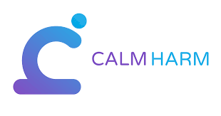

https://calmharm.co.uk
Calm Harm
Category: Mental Health
Free
App store
Google play
Calm Harm is designed for people who are trying to manage urges to self-harm.
Calm Harm is an award-winning app developed for teenage mental health charity stem4 by Dr Nihara Krause, Consultant Clinical Psychologist, using the basic principles of an evidence-based therapy called Dialectical Behavioural Therapy (DBT).
Calm Harm provides tasks to help you resist or manage the urge to self-harm. You can make it private by setting a password, and personalise the app if you so wish. You will be able to track your progress and notice change.
Please note the app is an aid in treatment but does not replace it

Catch It
Category: Mental health
Free
Learn how to manage feelings like anxiety and depression with Catch It. The app will teach you how to look at problems in a different way, turn negative thoughts into positive ones and improve your mental wellbeing.
Category: Mental health
Free
Learn how to manage feelings like anxiety and depression with Catch It. The app will teach you how to look at problems in a different way, turn negative thoughts into positive ones and improve your mental wellbeing.

Chill Panda
Categories: Mental health, Child health
Being tested in NHS
Free
Learn to relax, manage your worries and improve your wellbeing with Chill Panda. The app measures your heart rate and suggests tasks to suit your state of mind. Tasks include simple breathing techniques and light exercises to take your mind off your worries.

distrACT
Category: Mental health (adult)
Free
The distrACT app gives you easy, quick and discreet access to information and advice about self-harm and suicidal thoughts.
The content has been created by doctors and experts in self-harming and suicide prevention.

The distrACT app aims to help you better understand urges to self-harm, and encourages you to monitor and manage your symptoms. ... In the app's Chill Zone, you can find resources that may help you feel better, including art, books, films, music, poems, quotes, stories and online videos.
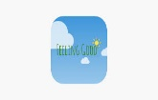
Feeling Good: positive mindset
Category: Mental health
Free, with in-app purchases
Relax your body and mind with a series of audio tracks designed to help you build confidence, energy and a positive mindset.
Who is it suitable for?
Anyone aged 18 or over who feels worried or stressed, and those who want to improve their mental wellbeing, concentration and confidence in all walks of life.
How does it work?
Feeling Good uses relaxation, cognitive behavioural therapy (CBT) and resilience building techniques from sport to help improve positive feelings, self-esteem and self-confidence.
To get you going, the app offers 4 free audio tracks combining soothing music with gentle coaching.
The main offering is the 12-track Positive Mental Training audio programme, which is available as an in-app purchase. This programme has been used by the NHS in Edinburgh for the last 12 years to help recovery from stress, anxiety and depression.
The app allows you to set reminders to listen to the tracks, as repeated listening is believed to build resilience and help reinforce the skills learned in the programme.

Stress & Anxiety Companion
Category: Mental health
Free, with in-app purchases

Stress & Anxiety Companion helps you handle stress and anxiety on-the-go. Using breathing exercises, relaxing music and games designed to calm the mind, the app helps you change negative thoughts to help you better cope with life's ups and downs. This app has been updated and is currently under reassessment.

Student Health App
Categories: Healthy living, Mental health
Free
The Student Health App provides easy access to more than 900 pages of reliable health information all in one place. The content has been created for university students by NHS doctors and is regularly updated.
Use the app to reduce your worries, feel more confident and get the support you need at what can be a challenging time for any student.

Anxiety tools right in your pocket
Anxiety is an extremely common but nonetheless extremely disruptive experience. Dealing with anxiety can mean sleepless nights, missed opportunities, feeling sick and full-blown panic attacks that can keep you from feeling like your full self.

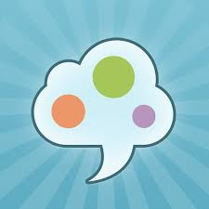
Https://Sam-app.org.uk
SAM anxiety management app. (NHS app)
iPhone
Android
Free app
Stress, Anxiety and Compassion (NHS app) mild to moderate anxiety anxiety. The app has been developed in collaboration with a research team from UWE, Bristol

Non NHS apps
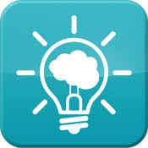
MindShift App
MindShift is a free app designed to help teens and young adults cope with anxiety. It can help you change how you think about anxiety. ... Offers strategies to manage worry, panic, conflict, ordinary anxiety, and three specialised categories of anxiety: test axiety, social anxiety, and perfectionism. Anxiety Canada, a world leader delivering evidence-based mental health relief through digital channels, has released MindShift™ CBT for iOS and Android, free to download and use for all Canadians. It employs scientifically proven strategies based on Cognitive Behavioural Therapy (CBT) to help users learn to relax and be mindful, develop more effective ways of thinking, and use active steps to take charge of their anxiety.

https://www.headspace.com/
Headspace
iPhone rating: 4.9 stars
Android rating: 4.5 stars
Price: Free with in-app purchases
Headspace is a cutely designed guided meditation app and so much more. With targeted meditations led by a former monk on sleep, happiness, productivity, mindful use of technology, and dozens of other topics, Headspace can help bring balance and peace across all aspects of daily life. A consistent mindfulness practice with Headspace can help you develop better focus, decrease your stress, and become less reactive to your anxiety triggers. Use the app to track your time in mindfulness training and invite friends to join in with you.
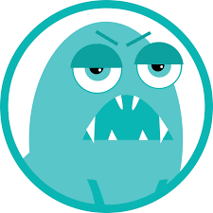
https://rootd.io
Rootd
iPhone rating: 4.6 stars
Android rating: 4.1 stars
Price: Free with in-app purchases
Downloading Rootd means you can work on improving your panic and anxious mood while supporting a female-led app. In addition to mindfulness exercises and step-by-step guides to tactics such as deep breathing, the app features an emergency contact button that makes it simple to call a loved one or hotline when you’re in distress. The Personal Stats Page is another source of encouragement, as it tracks the number of panic attacks you’ve overcome and the number of in-app lessons you’ve completed.

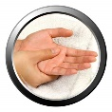
Acupressure: Heal Yourself
iPhone rating: 3.3 stars
Android rating: 4.3 stars
Acupressure is the art of relieving pain and tension through pressure point massage, a practice with roots in Chinese medicine dating back over 2,000 years. Because it uses your fingertips, it’s safe to do on yourself or others. This app is an illustrated guide to locating the pressure points that can help relieve many symptoms of anxiety, such as muscle tension, headache, and indigestion. Search for your symptom and the app will direct you to the pressure points you can target for relief.

Stop Panic & Anxiety Self-Help
Android rating: 4.4 stars
Price: Free
Panic attacks can be intense. This self-help app reminds you of your strengths and ability to cope when panic is triggered. A diary within the app is built to help you notice and challenge the thinking that leads to panic. The app also features audio content and reading that empowers you with the cognitive behavioural therapy-based techniques that can help shut panic attacks down. Panic Assistance audio is your voice of reason mid-panic attack, while the Emotional Training track helps you reconfigure your thoughts and associations to bring more calm into your life.

Sleep Time
iPhone rating: 4.7 stars
Android rating: 4.1 stars
Price: Free with in-app purchases
Sleep has a huge impact on your mood and emotional regulation. Make the most of it with the Sleep Time app, a sleep analysis app complete with a toolbox full of gentle soundscapes, an alarm clock, and wake-up algorithm. Just by placing your phone on your bed, you can track your sleep time and cycles. When used consistently, the app’s automated analysis charts make it easy to notice trends in when you get the most restful sleep and what tends to keep you up.

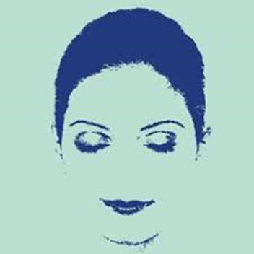
Relax & Rest Guided Meditations
iPhone rating: 4.8 stars
Android rating: 4.5 stars
Price: $1.99
Meditation is a practice recommended by many therapists for its stress-relieving benefits. This app walks you through meditations that focus on the breath, the body, and deep relaxation. Depending on your practice, you can choose from a 5-, 13-, or 24-minute session. No prior experience is necessary, as the audio meditations walk you through step by step. Plus, extra reading will teach you more about meditation and how to bring about the best results.

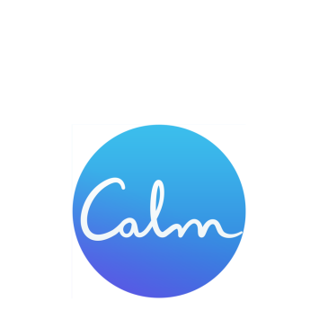
www.calm.com
Calm
iPhone rating: 4.8 stars
Android rating: 4.5 stars
Price: Free with in-app purchases

Sleep, meditation, and relaxation are in your hands with Calm, another popular mindfulness app. These guided meditations are perfect for complete novices through seasoned practitioners, and you have your pick when it comes to how long you can dedicate to the app each day. Sleep is important for managing stress, but it’s also one of the first things to become problematic when you’re anxious. In addition to an assortment of daily meditations, Calm features nature sounds and sleep stories — yes, an effective concept taken from childhood — to help lull you into relaxed sleep.

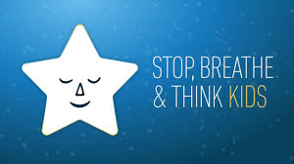
Stop, Breathe, and Think
iPhone rating: 4.8 stars
Android rating: 4.4 stars
Price: Free with in-app purchases

Stop, Breathe, and Think is your daily mindfulness app that also prompts you to input how you’re feeling. Select your mood when you open the app and it will suggest the meditations, yoga sequences, or acupressure that could serve you best in that moment, from deep breathing exercises to body scans to visualizations. The check-in feature also allows you to track your moods and progress, so you can examine what you feel most and focus on taming or understanding those anxieties better.

Colorfy
iPhone rating: 4.8 stars
Android rating: 4.5 stars
Price: Free with in-app purchases
Colorfy is an adult colouring book brought into the digital realm. With a selection of images and mandalas to choose from, or the option to upload your own sketches to colour, you can spend hours in a flow state or focused meditation through this app. Pouring your attention into the beautiful designs can distract from your anxious thoughts and help calm you down. Self-critique is out the window, too, as the simple click-to-fill function of the app means you’ll never stray outside the lines.

Dare — Break Free From Anxiety
iPhone rating: 4.8 stars
Android rating: 4.7 stars
Price: Free with in-app purchases
Dare to face your fears, whether you’re dealing with anxiety, panic, worry, or insomnia. The Dare app can walk you through audio recordings to help you sit comfortably with your anxiety rather than avoiding it, a tactic that can just make anxiety worse. On-screen guides give you something to focus on while you breathe deeply, and plenty of additional helpful content is available behind the subscription.

Nature Sounds Relax and Sleep
Android rating: 4.3 stars
Price: Free with in-app purchases
Racing thoughts and ruminations are hallmarks of anxiety, but you can slow down, breathe deeply, and clear your thoughts with the gentle sounds and sights of nature in this app. From thunder and rain to crackling fires to bird sounds and more, there’s something for everyone. Set the app timer to listen while you gently drift off to sleep, or set one of the tracks as your morning alarm so you can start your day with something less anxiety-inducing than the standard beeping.

https://youngminds.org.uk/about-us/youngminds-people/
YoungMinds People

Meet the people who work every day to improve the emotional health and wellbeing of children and young people in the UK.

