

**LOOKING AFTER YOUR MENTAL HEALTH WHILST AT HOME**

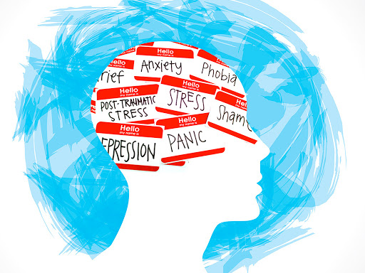

**Talk about how you feel:**

Talking about your feeling can help you gain understanding about your feelings which helps build your resilience (your ability to bounce back).

**Exercise:**

Regular exercise can boost your self-esteem helping you to maintain a positive frame of mind. It tires your body which encourages healthy sleep and keeps you mind and body fit/healthy not to cause additional strain on your mental health. .

**Eat well:**

Your brain needs a mix of nutrients in order to stay healthy and function well.

**Take time:**

Stop, have a change of scene or a change of pace, it is good for your mental health. Sit in the moment for a few minutes and let the world go by.

**Seek help:**

None of us are superhuman. We all sometimes get tired or overwhelmed by how we feel or when things don’t go to plan. If things are getting too much for you and you feel you can’t cope, ask for help. Family is a good place to start a can sometimes offer practical help.

**Do something nice:**

Caring for others is often an important part of keeping up relationships with people close to you. It can even bring you closer together, build your self-esteem and encourages positivity.

**Be you:**

We’re all different. It’s much healthier to accept that you’re unique than to wish you were more like someone else. Feeling good about yourself boosts your confidence to learn new skills.

**Find fun:**

What do you love doing? What activities can you lose yourself in? What did you love doing in the past?

Enjoying yourself can help beat stress. Doing an activity you enjoy probably means you’re good at it, and achieving something boosts your self-esteem

**Stay in touch:**

There’s nothing better than catching up with someone. Right now face to face may be difficult. You can try giving them a call, drop them a note, or chat to them online instead.