November 2022
Support with ParentPay:
If you need help with a ParentPay problem we hope the following will help.
- You can click the FAQ on the Parent login page:

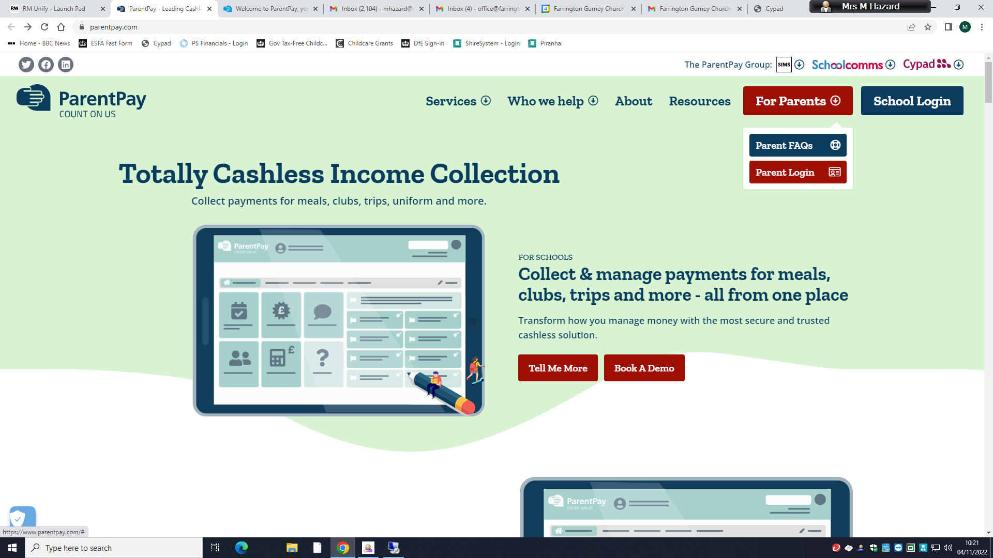

- Alternatively, you can email ParentPay directly at the following address:
parent-support@parentpay.com
*If you feel you have not received a response, please check your SPAM email box.

- Parents can complete the following help ticket by following this link: (copy & paste into your browser bar):
https://app.parentpay.com/FormsAPI/forms/contactus

4. Finally, there is also some information online on how you can report issues following this link: (copy and paste into your browser bar)
https://parent-support.parentpaygroup.com/hc/en-gb/articles/4416963652113-How-to-get-help#how-to-get-help-0-0

If you require a refund, a balance enquiry or have missed the dinner option deadline, please direct these to the office

