Term 1

This term will be investigating the autumn season, all about me and the harvest festival.
Autumn.  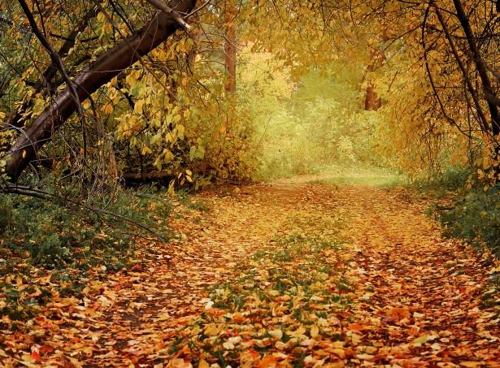  What happens to our environment during the autumn?  Let's explore.  How does it feel outside?  Investigate how the environment changes.  Investigating building materials. | 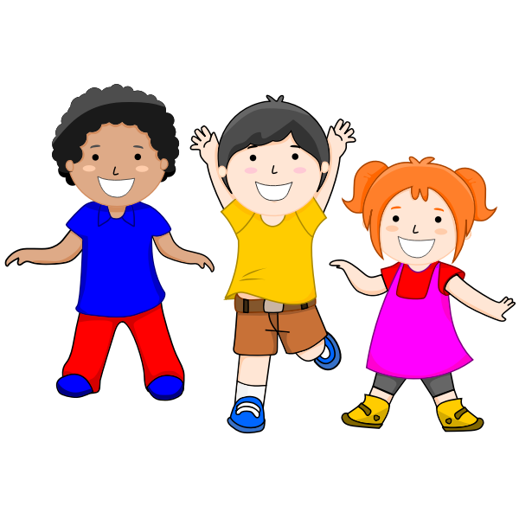  All about me.  What makes us special?  New routines, how do we feel?  Harvest.  What is harvest?  How do we celebrate the harvest festival?  Where does our food come from?  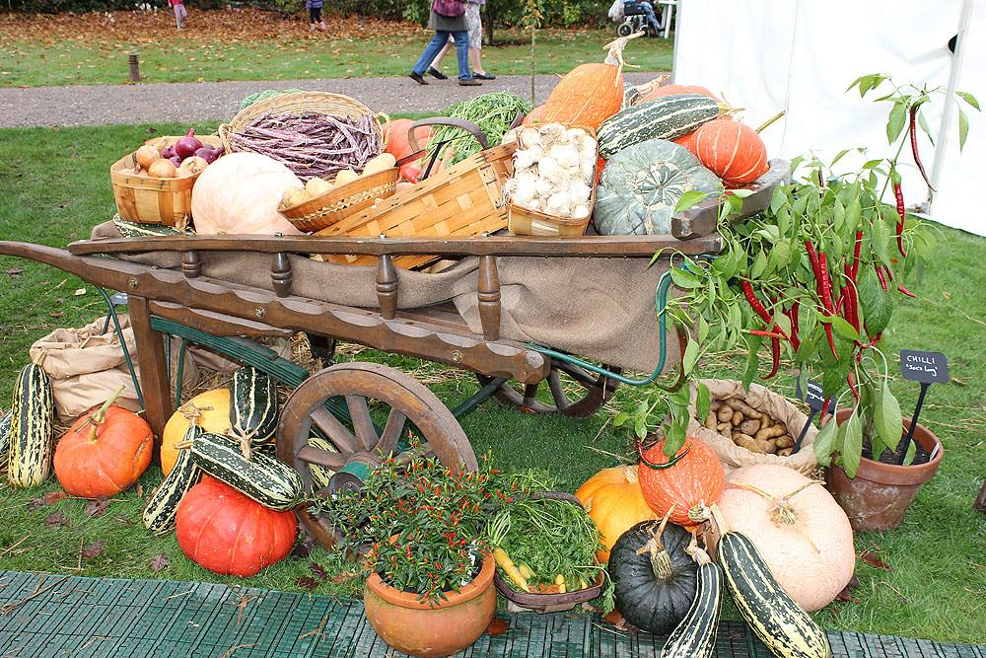
Our focus stories will be.  The Gruffalo  The little red hen  The 3 Billy goats | Vocabulary we will use and learn.  Autumn, conkers, pumpkins, leaves, texture,harvest, festival, share, vegetables, sharing, building, sturdy, flimsy, straw, wood, bricks.

