13th September 2023

School Trips 2023 - 2024

Dear Parent / Carer,

With family life becoming busier and finances stretched, we would like to give you the full year's forecast of trips for our children. We hope that you find this useful.

We do ask for a voluntary contribution towards trips. As you will be aware school finances across the country are an issue; therefore, if we do not receive a 95% total fee we unfortunately will not be able to allow the trip to go ahead. Trips fees will now show on your ParentPay account, you are welcome to start paying into these if you wish.

We have tried to keep costs as low as possible. If you feel you cannot make any contribution, please do speak to the school office as there may be some charities we can ask to make contributions but they make these decisions on a ‘case by case’ basis .

If we do not reach the 95% target we will ask families, if they wish, to make a donation to ‘top up’ funds. Please do not feel pressure to do this, only do it if you can; we have had many families ask if they can be given this choice before a trip is cancelled.

Reception

17th October 2023 - Palette & Pasture - Voluntary contribution of £14.60 (please pay & give consent via parent pay by 30th Sept)

Years 1 & 2

15th March 2024 - SS Great Britain - Price to be confirmed (please pay & give consent via parent pay by 10th February)

Year 3 & 4

16th October 2023 - Stonehenge - Voluntary contribution of £12.20 (please pay & give consent via parent pay by 30th September 2023)

18th June 2024 - Roman Baths - Voluntary contribution of £14.00. Prices may vary as they cannot confirm next year’s prices until later in the year. (please pay & give consent via parent pay by 24th May 2024)

Year 5 & 6

29th February 2024 - Swindon Steam Museum Voluntary contribution of £27.00 price may vary as they cannot confirm next year's admissions fees until later in the year (please pay & give consent via parent pay by 20th January 2024)

Whole school trip

23rd May 2024 - Longleat Voluntary contribution of £18.60 (please pay & give consent via parent pay by 30th April 2024)

Whole school local trips

Midsomer Norton Primary also aims to take children on visits to local community areas / parks / library / sports centres etc. throughout the year. Local trips consent are included in your child's data collection sheet. Please ensure these are completed and returned so that your child can attend the local visits.

If your child requires the school to provide them a packed lunch on any trip, please email the school office your child's sandwich filling preference a minimum of 10 days before the trip.

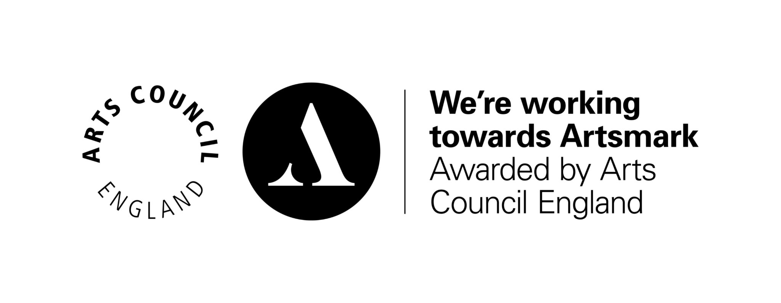
Best Wishes

The School Office

