St John’s Church of England Primary School
Literature Spine 2022-2023

 |  |  | KS1 |  | KS2
 | EYFS 1  Nursery | EYFS 2  Reception | Year 1 | Year 2 | Year 3 | Year 4 | Year 5 | Year 6
Week 1 and 2  Texts to support transition | Children choose their own stories for story time. (favourite books from home) | Children’s favourite texts.  Daily Story time voted by the children. | The Huey’s in the New Sweater by Oliver Jeffers  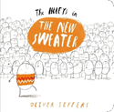 | The Day the Crayons Quit by Oliver Jeffers  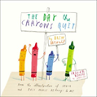 | The Dot by Peter H. Reynolds  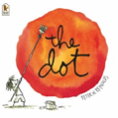 | Giraffes Can’t Dance by Giles Andreae  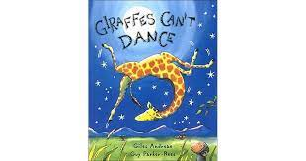 | Frog and Toad  By Arnold Lobel  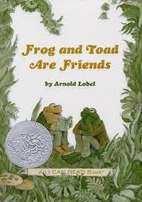 | The Huge Bag of Worries by Virginia Ironside  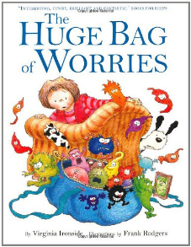
Term 1 + 2
Fiction | Freddie goes to  Playgroup by Nicola Smee  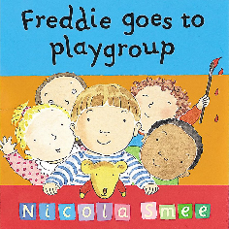  I wish I were Big! By Peter Bowman  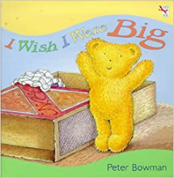  Owl Babies  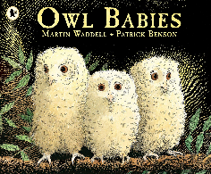  All kinds of babies  Brothers &Sisters  Just Because  If I had a hundred  Mummies by Vanda Carter  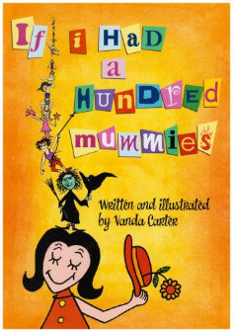  There’s a house  inside my  Mummy  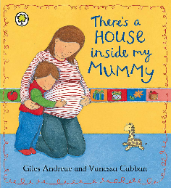  Guess how much I love  you  Never too Little to Love  What colour is love?  No matter what!  All Kinds of Beliefs  What I Believe  I am Peace  Peace is an Offering  The Peace Book  The Colour Monster | 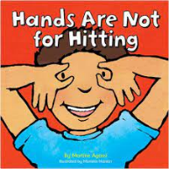Dogger by Shirley Hughes  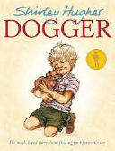  Ruby’s Worry by Tom Percival  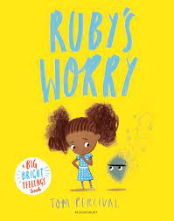  Rama and the Demon King  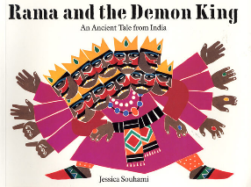  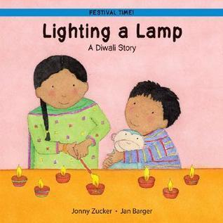  The First Christmas Story  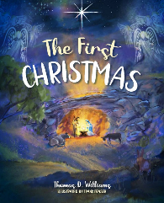  Kipper’s Birthday by Mick Inkpen  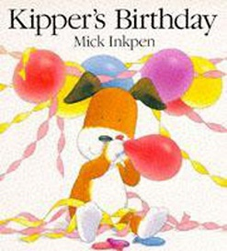 | 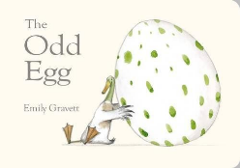  The Odd Egg by Emily Gravett  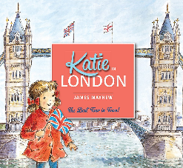  Katie in London by James Mayhew  The Queen’s Hat by Steve Anthony  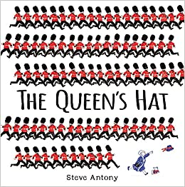  Last Stop on Market Street by Matt de la Pena  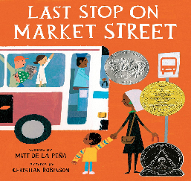  Julia Donaldson Texts  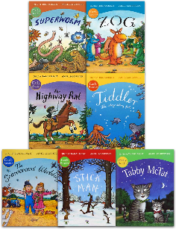 | The Tin Forest  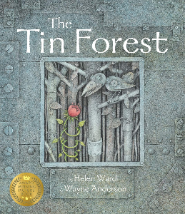  Stubby by Michael Foreman  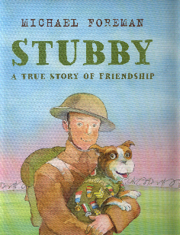  Flo of the Somme  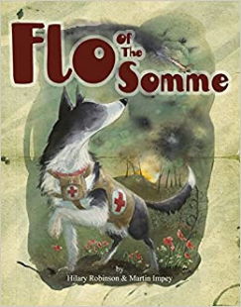  The Owl who was afraid of the dark by Jill Tomlinson  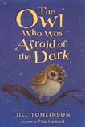  My Christmas Star - Model Text from The Write Stuff Planning. | The Squirrels that Squabbled by Rachel Bright  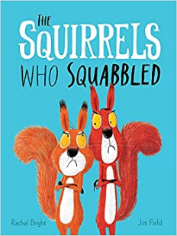  The Guard Dog by Dick King-Smith  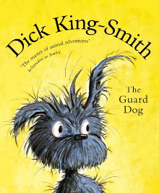  Winter’s Child by Angela McAllistar  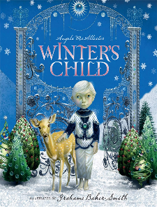  Marcy and the Riddle of the Sphinx by Joe Stanton  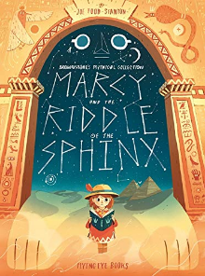  Flat Stanley by Jeff Brown  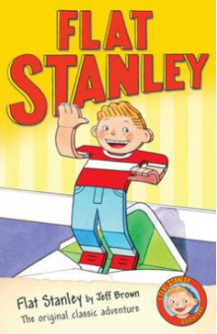  The Twits by Roald Dahl  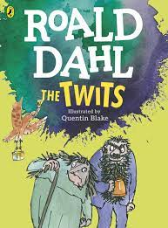  There’s a Pharaoh in our Bath! By Jeremy Strong  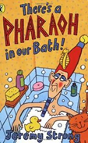 | Greek myths by Anthony Horowitz  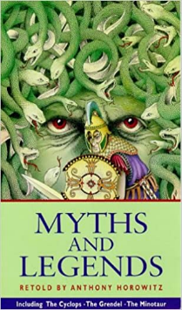  Class readers  The Wild Before  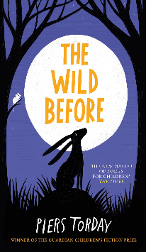  The Boy in the Dress  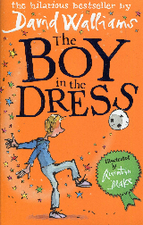  The Snowman  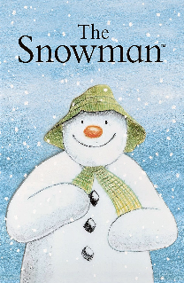  The boy at the back of the class  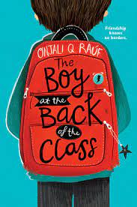  WCR / Read aloud  There’s a Boy in the Girls Bathroom  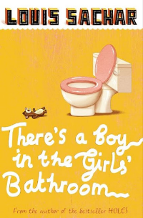 | The Explorer by Katherine Rundell  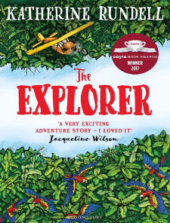  Asha and the Spirit Bird  By Jasbinder Bilan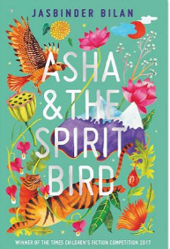  The Night I Met Father Christmas?  By Ben Miller  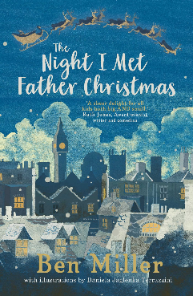  Tom’s Midnight Garden  Phillipa Pearce  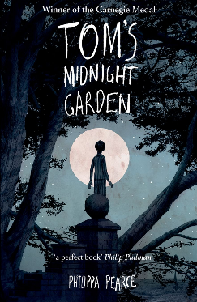  ‘Danny the Champion of the World’ by Roald Dahl  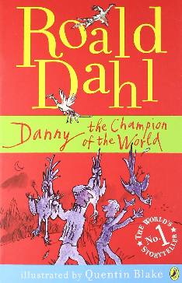  ‘Boom!’ by Mark Haddon  Harry Potter and the Philosopher’s Stone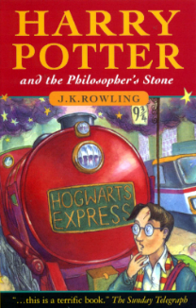  Scavengers by Darren Simpson  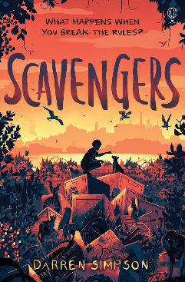 | Kensuke’s Kingdom  By Michael Morpurgo  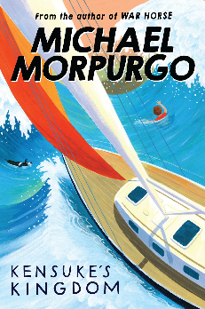  Hansel and Gretel by Neil Gaiman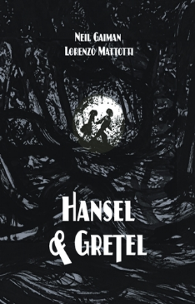Once by Morris Gleitzman  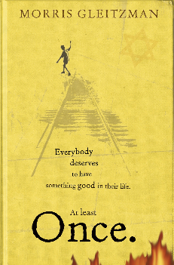  The Journey  Francesca Sanna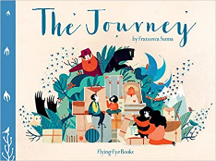  Clockwork by Philip Pullman  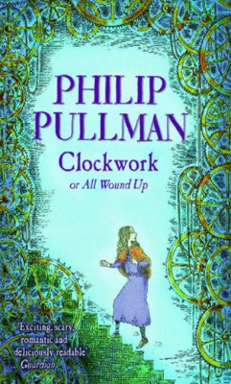
Non-Fiction | First Science- Materials  Exploring materials-  Wood, Metal  Plastic…  First science weather  Changing seasons | How to make a Chocolate Mug Cake ( Non fiction)  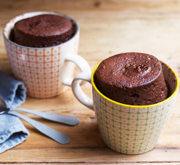 | 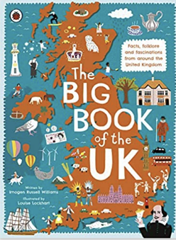  History -  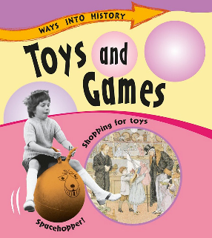 | 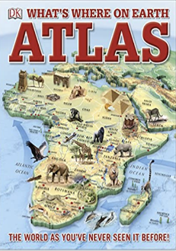  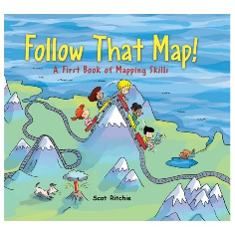  Follow That Map! By Scot Richie | Information texts: The Ancient Egyptians  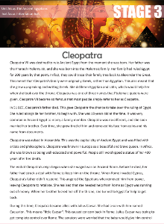  British Museum: So you think you’ve got it bad: A kid’s life in Ancient Egypt  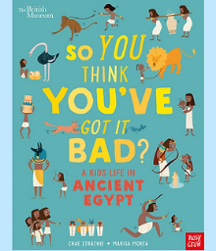 | Science -  Shackleton’s Journey by William Grill  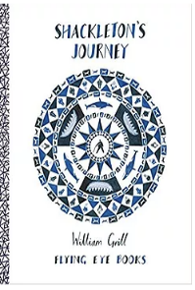  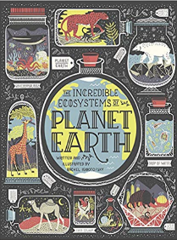 | Antarctica: The melting continent  By K. Young  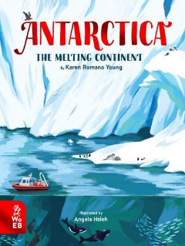  A Visual Introduction to Penguins  By Bernard Stonehouse, Martin Camm  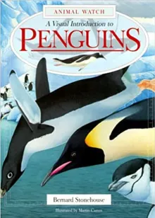
Poetry | Rhyming stories  What are little girls made of?  Nursery rhymes and action songs | Rhyming stories  Nursery Rhymes and songs | ‘Firework Night’  by Andrew Collett | In Flanders Fields, by John McRae | ‘The Eagle and the Crocodile’ by Lewis Caroll  ‘Firework Night’ by Enid Blyton  Revolting Rhymes by Roald Dahl | WW1 poetry: The Soldier by Rupert Brooke  In Flanders Fields, by John McRae  Dulce et Decorum Est By Wilfred Owen  The Sounds in the Evening by eleanor Farjeon  The Listening Station by Chrissie Gittins | I wandered lonely as a cloud by William Wordsworth  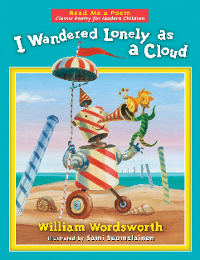  ‘Colonel Fazackerly Butterworth-Toast’ By Charles Causley  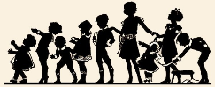  Sticky McStick Stick by Michael Rosen  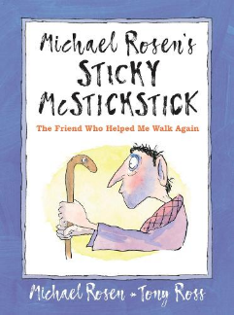 | The Jumblies  by Edward Lear  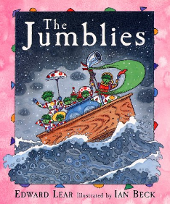Colonel Fazackerley Butterworth-Toast  by Charles Causley 