 |  |  |  |  |  | KS1 |  |  |  | KS2
 |  | EYFS 1  Nursery |  | EYFS 2  Reception |  | Year 1 |  | Year 2 |  | Year 3 |  | Year 4 | Year 5 |  | Year 6
Term 3 + 4

Fiction | - Dinosaurs Love Underpants  - If I were a dinosaur  - Harry and his Bucketful of Dinosaurs  - The Dinosaur that Pooped a Planet  - Mad about Dinosaurs  - Dear zoo story sack  - Elmer  - The Animal Boogie  - Brown Bear, Brown Bear, What do you See?  - Goldilocks  - Farmer Duck  The Very Hungry Caterpillar  Miffy (story sack)  The Little Red Hen  Mad about Minibeasts  Oliver’s Vegetables  Sam Plants a Sunflower  Growing Frogs  The Teeny Weeny Tadpole  Who’s in the egg?  - Superworm  - What the Ladybird Heard  - The Gruffalo  - We’re going on a bear hunt  The Three Wishes  Wisp - A story of Hope by Zana Fraillon  That’s not a daffodil  How do you make a rainbow? |  | Goldilocks and the Three Bears  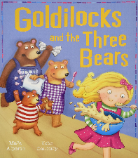  Three Billy Goats Gruff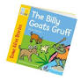  The Gingerbread Man  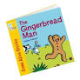  Whatever Next  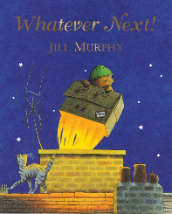  Aliens Love Underpants  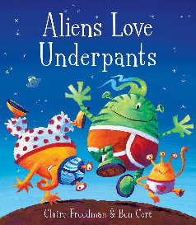  The Three Little Pigs  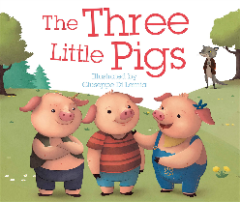  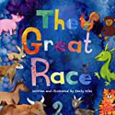  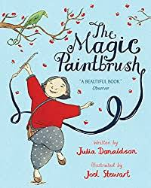  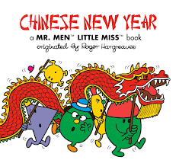  We’re Roaming through the Rainforest  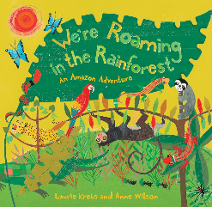  The Mixed Up Chameleon  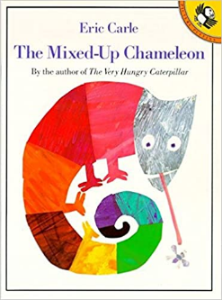  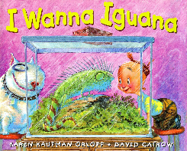  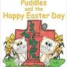 |  | Harry and the Bucketful of Dinosaurs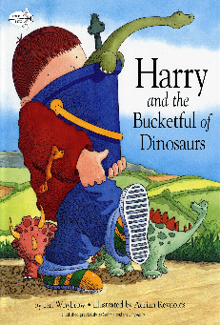  The Train Ride by June Crebbin  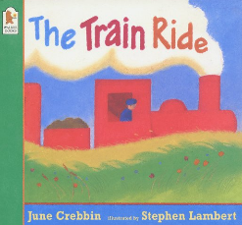 |  | How to Hide a Lion by Helen Stephens  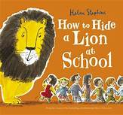  Esio Trot by Roald Dahl  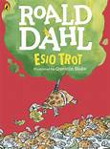  The Enormous Crocodile by Roald Dahl  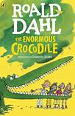  The Pirates next door by Jonny Duddle  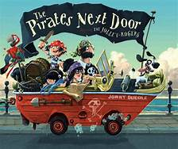  The Marvelous Fluffy Squishy Itty Bitty by Beatrice Alamagna  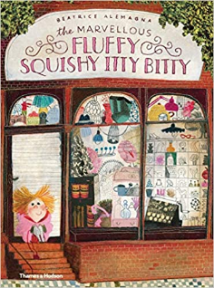  George and the Dragon by Chris Wormell  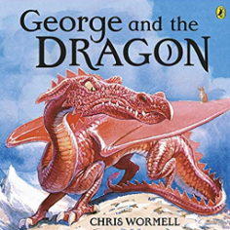 |  | The Secret of Black Rock by Joe Todd Stanton  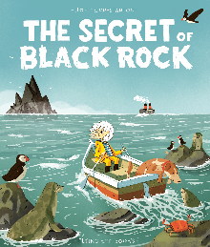  A mummy ate my homework! By Thiago de Moraes  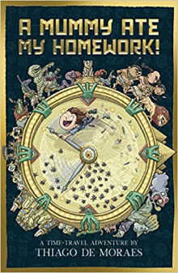  The Velveteen Rabbit by Margery Williams  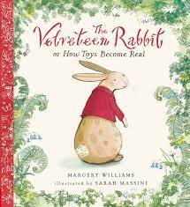  Charlotte's Web by E. B White  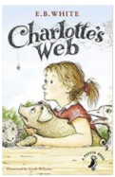  The Abominables by Eva Ibbotson  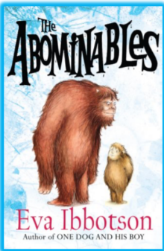  The True Story of the Three Little Pigs by Jon Scieszka  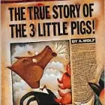  Stone Age Boy by Satoshi Kitamura  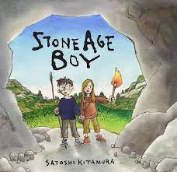 |  | Malala’s Magic Pencil by Malala Yousafi  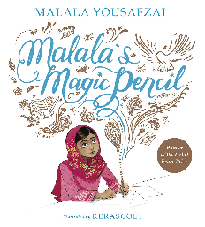  James and the Giant Peach  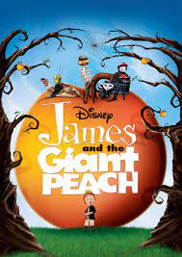  How to Train your Dragon by Cressida Cowell  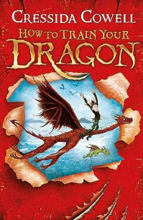  That Pesky Rat by Lauren Child  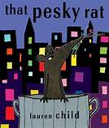  Alice’s Adventures in Wonderland by Lewis Caroll  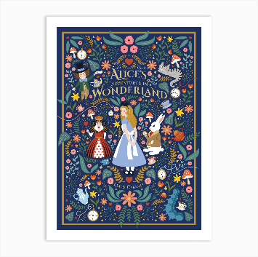  On Sudden Hill by Linda Sarah  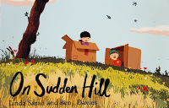 |  | Wolf Brother by Michelle Paver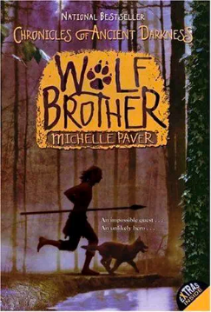  Black beauty by Anna Sewell  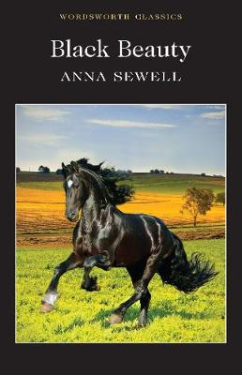  Holes by Louis Sachar  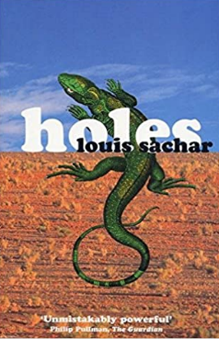  Can You See Me?  By Rebecca Westcott and Libby Scott  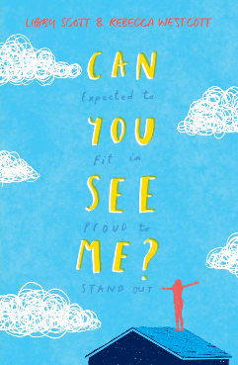 | Arctic Star by Tom Palmer  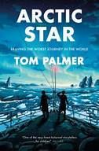  A Series of Unfortunate Events by Lemony Snicket  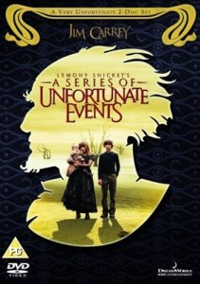
Non-Fiction | Exploring life cycles  Tadpole to frog  Egg to chick  Caterpillar to butterfly  Pup to seal… |  | 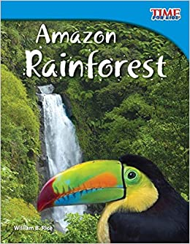 |  | Questions and answers about Dinosaurs 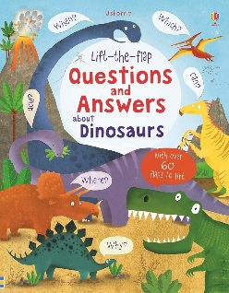 |  | Pirates - Model Text from The Write Stuff Planning.  Children’s illustrated atlas by Andrew Brooks  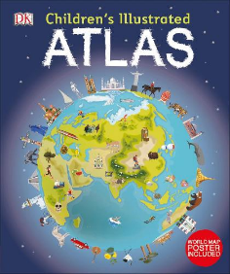  Collins Junior Atlas by Stephen Scoffman  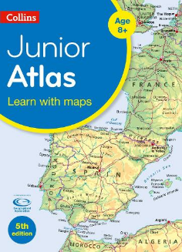  Victorian Books by Fiona Reynoldson  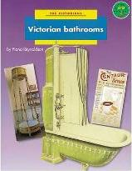  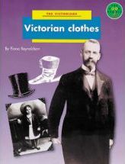  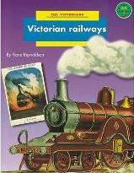 |  | Information texts: The Ancient Egyptians  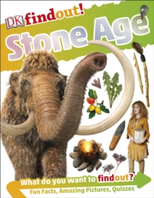  Skara Brae by Dawn Finch  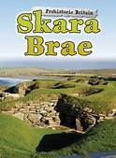 |  | Non-fiction texts on Italy  Report writing  The Man Who Walked Between two Towers  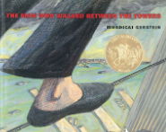 |  | What a Waste by Jess French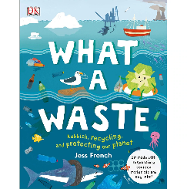  The Pebble In My Pocket 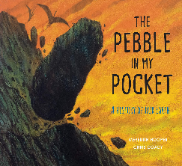  Fair Trade  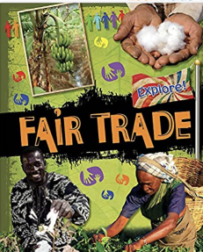 | Science - Charles Darwin on the Origin of Species  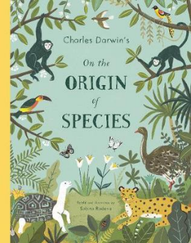  Moth by Isabel Thomas  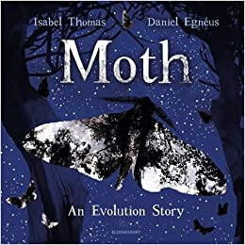  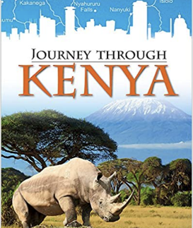
Poetry | Rhyming stories  What are little girls made of?  Nursery rhymes and action songs |  | Rhyming Stories  Nursery Rhymes and Songs |  |  |  | ‘If I Were in Charge of the World’  by Judith Viorst. |  | Tiger, Tiger, Burning Bright by Fiona Waters  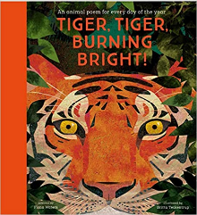  Revolting Rhymes by Roald Dahl  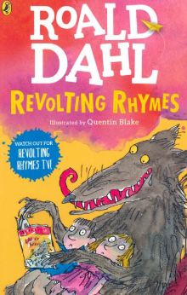 |  | Chocolate Cake by Michael Rosen  The Sound Collector by Roger McGough  Auld Lang Syne and My Hearts in the Highlands by Robert Burns  The Magic Box by Kit Wright  Pinda Cake by Valerie Bloom  Benjamin Zephaniah - Football Crazy |  | The Listeners by Walter de la Mare  