 |  |  | KS1 |  | KS2
 | EYFS 1  Nursery | EYFS 2  Reception | Year 1 | Year 2 | Year 3 | Year 4 | Year 5 | Year 6
Term 5 + 6

Fiction | The Train Ride (story sack)  Duck in the Truck  The Journey Home from Grandpa’s  The Big Blue Train  Duck’s Day Out  Pirates’s Love Underpants  Ten Little Pirates  That's Not My Pirate  Going to school  The Colour Monster Goes to School  Harry and the Dinosaurs go to School  See Inside your Body  Why Shouldn’t I Eat Junk Food?  Staying Safe in the Sun  Aliens Love Underpants  Little princess, I want my Potty!  I’m Sorry  Best Friends or Not?  Is That What Friends Do?  Don’t Call me Special  Whoever You Are  My World your World  Handa’s surprise  Don’t tell lies Lucy!  Tell the truth | 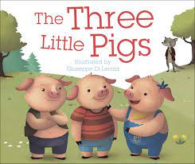  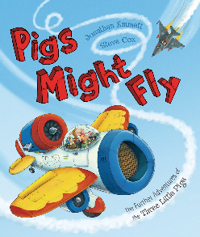  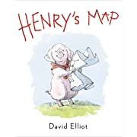  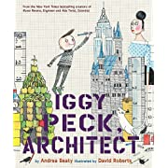  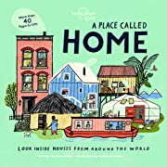  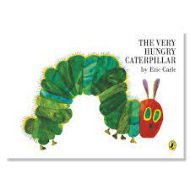  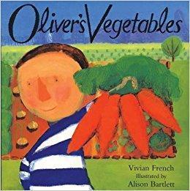  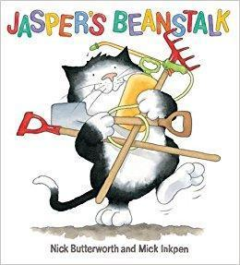  Eddie's Garden –Sarah Garland  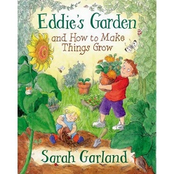  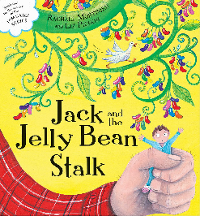 | Grandad’s Island by Benji Davies  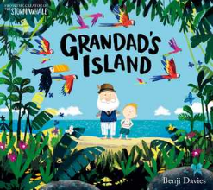  Little Red Riding Hood by Lari Don  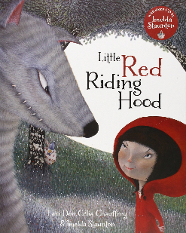  The Story of Pinocchio by Katie Daynes  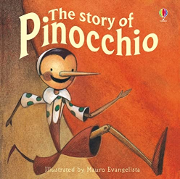 | Little Red Reading Hood by Lucy Rowland  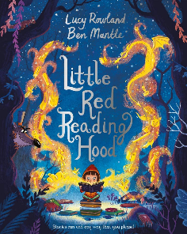  Agents of the wild: Operation Honey Honeyhunt  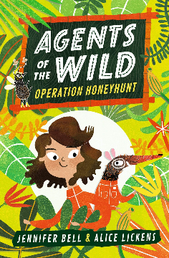  Heather has two Mummies by Leslea Newman  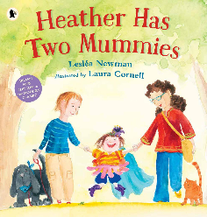 | Voices in the Park by Anthony Browne  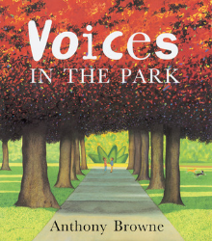  The Proudest Blue by Ibtihaj Muhammad  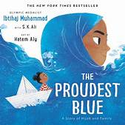  The Wind and the Willows by Kenneth Graheme  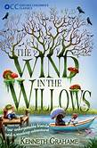  The Butterfly Lion by Michael Morpurgo  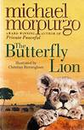  The Queen’s Nose by Dick-King Smith  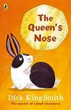 | The Tale of Despereaux  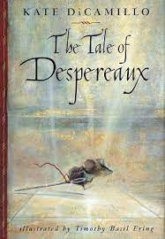  and  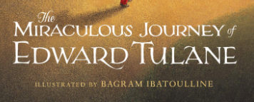  The Miraculous Journey of Edward Tulane  By Kate DiCamillo  The Giraffe, the Pelly and me by Roald Dahl  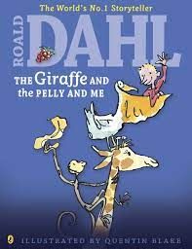  Danny Champion of the World by Roald Dahl  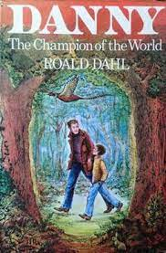  Paddington by Michael Bond  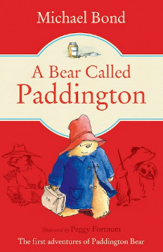  Aeosop’s Fables  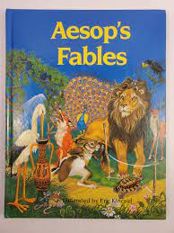  Brothers Grimm Traditional Tales  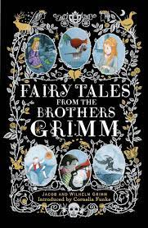  Alice in Wonderland by Lewis Caroll  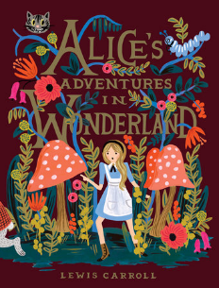  The Lion the Witch and the Wardrobe by C.S Lewis  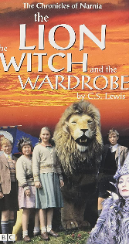 | Cosmic by Frank Cottrell Boyce  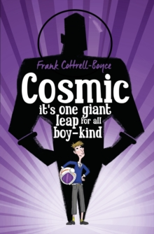  The Rain Player by David Wisniewski  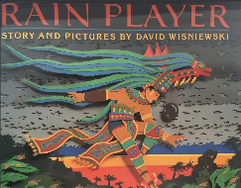  Rain Reign  By Ann M. Martin  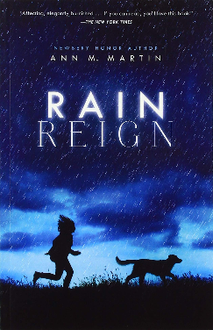 | Wonder by R. J Palacio  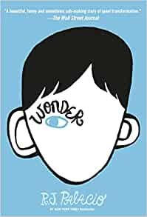  George’s Marvellous Medicine by Roald Dahl  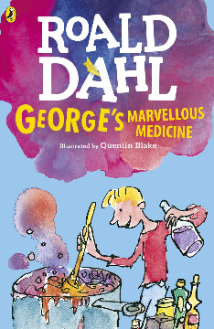  The Shakespeare Stories by Andrew Matthews & Tony Ross  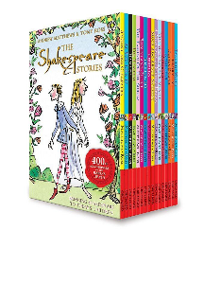
Non-fiction | Amazing machines (dazzling diggers, cool cars, terrific trucks…)  Sparklers senses  See inside your body | 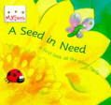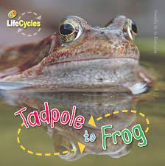 |  | Sydney City Trails  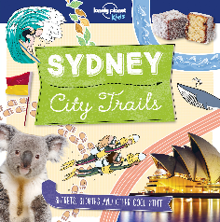  Shapes of Australia by Bronwyn Bancroft  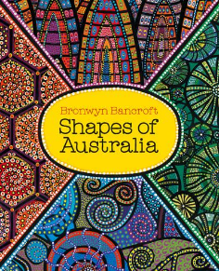  The Great Fire of London by Liz Gogerly  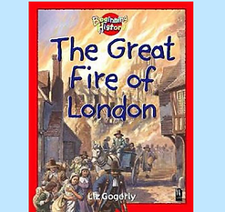 | The Stone Age: Hunters, Gatherers and Woolly Mammoths by Marcia Williams  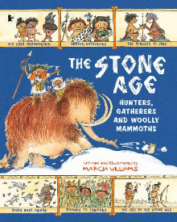  Stone Age to Iron Age by Clare Hibbert  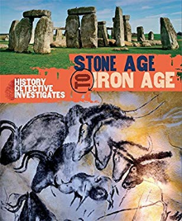  Young, Gifted and Black by Jamia Wilson  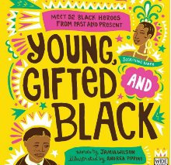 | Letter writing  Of Thee I Sing by Barack Obama  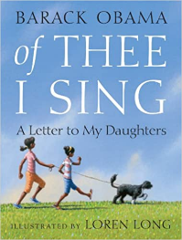  The Hill We Climb  Amanda Gorman | Everest by Alexandra Stewart  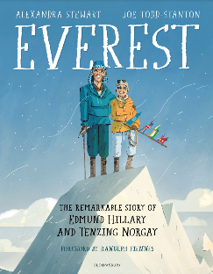  On the origin of specifies  Charles Darwin  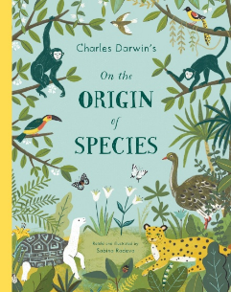  What’s where on Earth Atlas? By DK Children  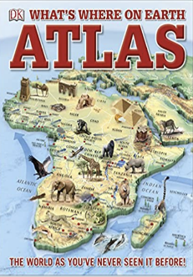  Queen Elizabeth II: Little Leaders  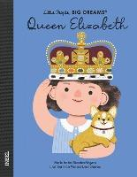
Poetry | Rhyming stories  What are little girls made of?  Nursery rhymes and action songs | 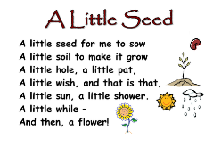 |  |  | The Lion and Albert by Marriott Edgar  My Shadow by R L Stevenson |  | Television by Roald Dahl  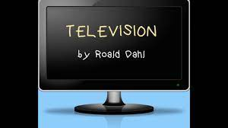  Rhythm of Life/ Hand on the Bridge by Michael Rosen  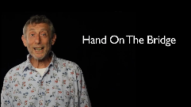  The Highwayman by Alfred Noyes  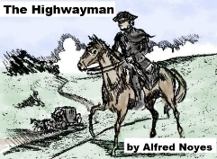  Football Mad by Benjamin Zephaniah  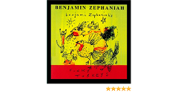  The Treasures by Clare Bevan  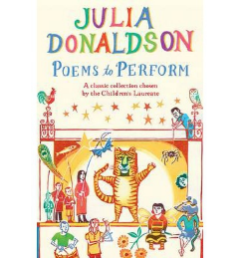
Whole School |  | 