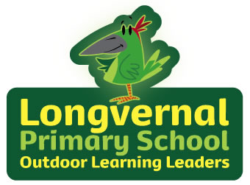

**English**

**Writing**

Writing will be themed around our class novel and other short stories.

* Setting and character descriptions
* Narrative writing
* Non chronological report- Isambard Brunel
* Recount

**Reading**

Whole class guided reading

Our Whole Class novel is James and the Giant Peach

**SPAG**

* Capital letters and full stops
* Commas in lists
* Exclamation and question marks
* Plurals
* Apostrophes for contraction and possession

**Phonics**- RWI Phonic program

**Spelling**

RWI spelling program and personal spellings

**PE**

Dance Unit- Plants

**Maths**

Magic Maths

Multiplication and Division

Statistics

Properties of shape

**Science**

Habitats

Plants and animals

**RE**

Christianity-Salvation.

**History/ Geography**

Significant Victorians.

-Florence Nightingale

-Mary Seacole

-Isambard Kingdom Brunel

**Music**

‘I wanna be in a rock band’

Listen and Appraise

Musical Activities

Perform Song

**PSHE**

Celebrating Difference

**Computing**

Effective searching.

Questioning

**Art/DT**

Pattern and printing.

Featured artists: William Morris and L.S. Lowry

**Forest**

Fire, Tools, Play, Nature, Craft, Circle Time

Chestnut Class

Year 2

Spring Term 1