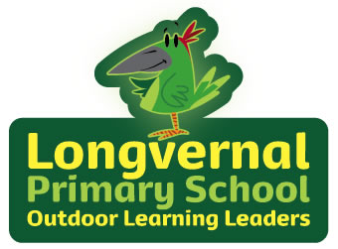

**Science**

Forces

Light and Shadow

**MFL**

Traditional French stories and playground songs

**Maths**

Times Tables Rockstars

Division

Multiplication

Fractions

**DT**

Cooking seasonal food

**PE**

Gymnastics

**PSHE**

Dreams and Goals

Ambitions

New Challenges

Celebrating Learning

Anti-bullying week

**RE**

**Islam**

**Beliefs**

**Prayer**

**Iman**

**History/ Geography**

Our European Neighbours

Human and Physical features

Capital Cities

**Music**

Glockenspiels

Listen and Appraise

Musical Activities

Perform

**Computing**

Spreadhseets

**Art**

**Famous Artists**

**Impressionism and post-impressionism.**

Renoir, Van Gogh, Monet.

**Forest**

Fire, Tools, Play, Nature, Craft, Circle Time

Maple Class

Year 3/4

Spring Term 1

**English**

**Writing**

Writing will be themed around our class novel Matilda

* Character description
* Setting description
* Story writing

Non-chronological report based on Europe

**Reading**

Our class novel is Matilda

Whole class guided reading

**SPAG**

* Fronted adverbials
* Reported and direct speech
* Main and subordinate clauses

**Spelling**

No nonsense spelling and personal spelling lists