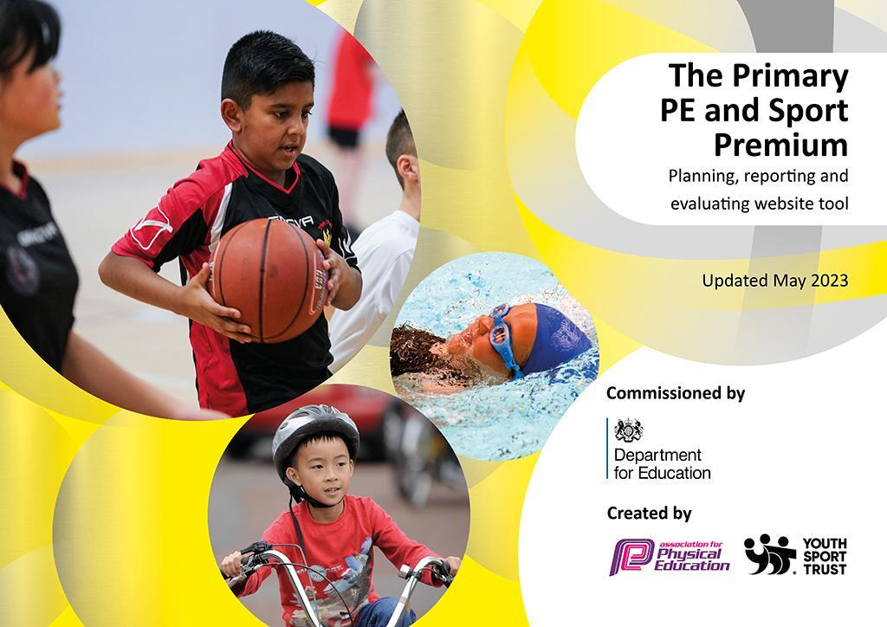
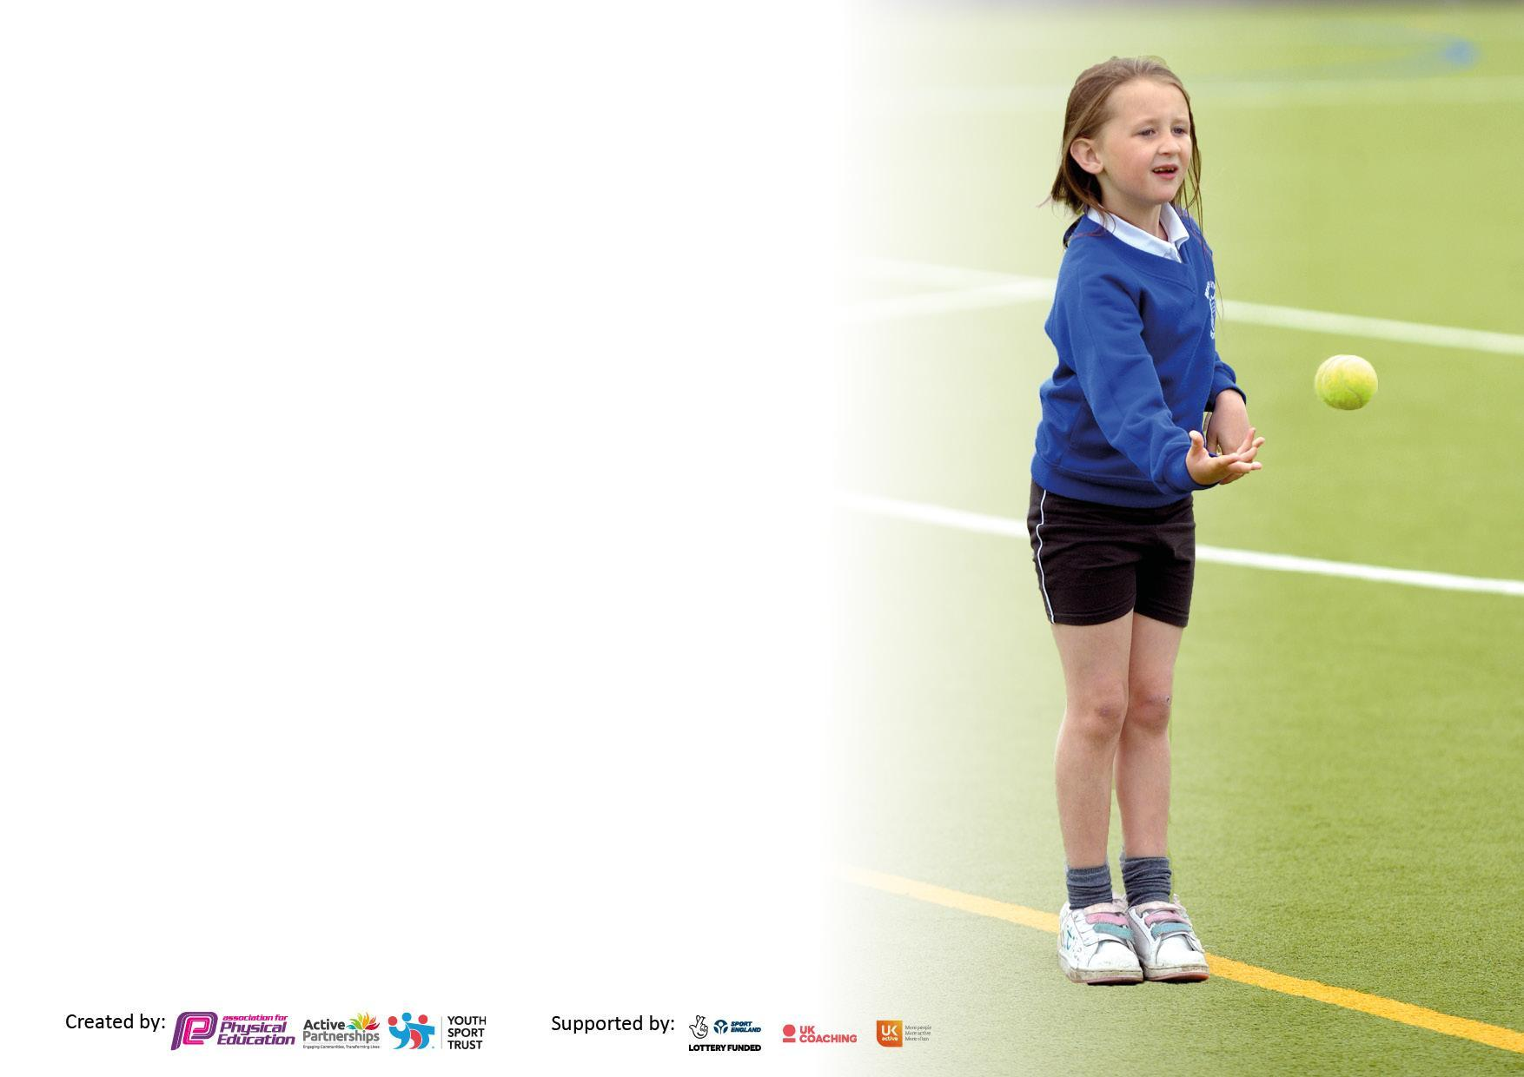

It is important that your grant is used effectively and based on school need. The Education Inspection Framework makes clear there will be a focus on ‘whether leaders and those responsible for governors all understand their respective roles and perform these in a way that enhances the effectiveness of the school’.

Under the Quality of Education Ofsted inspectors consider:
Intent - Curriculum design, coverage and appropriateness
Implementation - Curriculum delivery, Teaching (pedagogy) and Assessment
Impact - Attainment and progress

To assist schools with common transferable language this template has been developed to utilise the same three headings which should make your plans easily transferable between working documents.

Schools must use the funding to make additional and sustainable improvements to the quality of Physical Education, School Sport and Physical Activity (PESSPA) they offer. This means that you should use the Primary PE and sport premium to:

- Develop or add to the PESSPA activities that your school already offer
- Build capacity and capability within the school to ensure that improvements made now will benefit pupils joining the school in future years
- The Primary PE and sport premium should not be used to fund capital spend projects; the school’s budget should fund these.

Pleasevisitgov.ukfortherevisedDfEguidanceincludingthe5keyindicatorsacrosswhichschoolsshoulddemonstrate animprovement.Thisdocumentwillhelpyoutoreviewyourprovisionandtoreportyourspend.DfEencouragesschools to use this template as an effective way of meeting the reporting requirements of the Primary PE and Sport Premium.

We recommend you start by reflecting on the impact of current provision and reviewing the previous spend.

Schools are required to publish details of how they spend this funding, including any under-spend from 2021/2022, as well as on the impact it has on pupils’ PE and sport participation and attainment. All funding must be spent by 31st July 2023.

We recommend regularly updating the table and publishing it on your website throughout the year. This evidences your ongoing self-evaluation of how you are using the funding to secure maximum, sustainable impact. Final copy must be posted on your website by the end of the academic year and no later than the 31st July 2023. To see an example of how to complete the table please click HERE.
Details with regard to funding
Please complete the table below.

Total amount carried over from 2021/22 | £
Total amount allocated for 2021/22 | £
How much (if any) do you intend to carry over from this total fund into 2022/23? | £0
Total amount allocated for 2022/23 | £19,200
Total amount of funding for 2023/24. To be spent and reported on by 31st July 2024. | £ 19,010
Swimming Data
Please report on your Swimming Data below.

Meeting national curriculum requirements for swimming and water safety.  N.B. Complete this section to your best ability. For example you might have practised safe self-rescue techniques on dry land which you can then transfer to the pool when school swimming restarts.  Due to exceptional circumstances priority should be given to ensuring that pupils can perform safe self rescue even if they do not fully meet the first two requirements of the NC programme of study | Yes
What percentage of your current Year 6 cohort swim competently, confidently and proficiently over a distance of at least 25 metres?  N.B. Even though your pupils may swim in another year please report on their attainment on leaving primary school at the end of the summer term 2022.  Please see note above | %
What percentage of your current Year 6 cohort use a range of strokes effectively [for example, front crawl, backstroke and breaststroke]?  Please see note above | %
What percentage of your current Year 6 cohort perform safe self-rescue in different water-based situations? | %
Schools can choose to use the Primary PE and sport premium to provide additional provision for swimming but this must be for activity over and above the national curriculum requirements. Have you used it in this way? | Yes (Booster classes in Summer term for those children who haven’t achieved the NC requirements for swimming)

Action Plan and Budget Tracking
Capture your intended annual spend against the 5 key indicators. Clarify the success criteria and evidence of impact that you intend to measure to evaluate for pupils today and for the future.

Academic Year: 2023/24 | Total fund allocated: £19,010 | Date Updated: September 2023
Key indicator 1: The engagement of all pupils in regular physical activity – Chief Medical Officers guidelines recommend that primary school pupils undertake at least 30 minutes of physical activity a day in school |  |  |  | Percentage of total allocation:
 |  |  |  | %
Intent | Implementation |  | Impact
Your school focus should be clear what you want the pupils to know and be able to do and about  what they need to learn and to  consolidate through practice: | Make sure your actions to achieve are linked to your intentions: | Funding allocated: | Evidence of impact: what do pupils now know and what can they now do? What has changed?: | Sustainability and suggested next steps:
- Increase the number and range of sporting opportunities across the school.  - Increase the range of outdoor active learning within the curriculum and physical development at break and lunchtimes.  - Organised physical activities at break and lunchtimes.  - Monitor PP and SEND engagement with PE and school clubs.  - Raised attainment for swimming in KS2.  - An increase in percentage of families walking to school. | - Encourage outdoor physical activity where possible.  - Introducing Wake n Shake.  - Training for Sports Council Play Leaders and SMSAs  - Sports Council to lead physical activity sessions at break times and lunchtimes  - SMSAs to be more competent in delivering small active sessions.  - External coaches to run a range of different lunchtime and afterschool sports clubs 3 x a week.  - Transport tracker to assess how children are coming to school - initiative to be put in place to increase PA levels. | Coaching provision £11,000  Swimming booster sessions £1250 | - Higher activity levels at all times of the day.  - More families opt for a physically active mode of transport to school.  - Families and children are active in the mornings.  - Pupils are motivated and enthusiastic towards physical activity in school.
Key indicator 2: The profile of PESSPA being raised across the school as a tool for whole school improvement |  |  |  | Percentage of total allocation:
 |  |  |  | %
Intent | Implementation |  | Impact
Your school focus should be clear what you want the pupils to know and be able to do and about  what they need to learn and to  consolidate through practice: | Make sure your actions to achieve are linked to your intentions: | Funding allocated: | Evidence of impact: what do pupils now know and what can they now do? What has changed?: | Sustainability and suggested next steps:
- Ensure all children are aware of the importance of a healthy lifestyle, including both diet and regular exercise.  - Ensure pupils are aware of sporting activities and achievements on offer across the school and outside of school.  - School Sports Council to take responsibility to be play leaders during playtimes to increase physical activity.  - Use sports to continue to improve and maintain high standards and behaviour at break and lunchtimes.  - Healthy snacks are encouraged and explanations are given for why they are much more beneficial. | - Monitor snacks with a healthy snack chart for each class.  - Sports coaches available for lunchtime clubs  - Sports coaches and teachers are to increase well being and team building activities.  - The school’s theme week focuses on healthy lifestyles.  - Observations of after school provision.  - Subject leader staff meeting to increase confidence and skills among staff.  - Use sport and physical activity activity for brain breaks and sensory activities.  - Monitor PP attendance in after school clubs.  - Support to receive platinum award in School Games Mark.  - Develop SSC leadership through the SSP development programme.  - SSC to be set up. | £140 First Aid Year 6 | Structured networking with colleagues will take place throughout the year  Instant access to CPD courses for all staff where appropriate- through employed sports coaches  Identification and challenge for selected Gifted and Talented children.  Improved wellbeing through enrichment activities and improved confidence.  Developing EYFS children’s balance skills after lockdown.  Staff up-skilled and confident to teach high quality PE curriculum.  Training available for ECT’s and other staff to enhance confidence.  Children across the academy experience a high- quality PE curriculum, which improves their skills.  Pupils act as leaders through a sporting council - older pupils engage other pupils in sporting/PE activities at playtimes etc. Increased collaboration between pupils from different year groups. Completing personal bests and scoring against year groups.  Nursery will be able to access facilities and resources.  Teachers will use a new assessment tracking wheel (Get Set 4 PE) to monitor ability and performance throughout the year.

Key indicator 3: Increased confidence, knowledge and skills of all staff in teaching PE and sport |  |  |  | Percentage of total allocation:
 |  |  |  | %
Intent | Implementation |  | Impact
Your school focus should be clear | Make sure your actions to | Funding | Evidence of impact: what do | Sustainability and suggested
what you want the pupils to know | achieve are linked to your | allocated: | pupils now know and what | next steps:
and be able to do and about | intentions: |  | can they now do? What has
what they need to learn and to |  |  | changed?:
consolidate through practice:
- Ensure that there are CPD needs-led sessions, with high quality coaching from internal and external providers.  - Ensure that staff feel supported in delivering and evaluating PE lessons across both key stages.  - PE Subject Leader to develop assessment opportunities with a particular focus on adaptations for SEND. | - Commit staff meeting time to Get Set 4 PE.  - Ensure all staff are happy with Get Set 4 PE and how to access lesson plans.  - Whole staff training based on assessment of PE.  - Pupil questionnaire.  - Team teaching available.  - External coaches providing support to ECTs and low-confidence teachers to deliver high quality teaching.  - External coaches working with SMSAs so upskill them and work with the Sports Council. | £2980 Playleaders | Lesson observations showing that teaching confidence has increased.  Teaching and learning is high quality. Children are able to know and remember more about PE and School Sport.  Children access a higher level of school sport internally but also at an external club level.  Assessment processes in place. SEND assessment activities re adapted.
Key indicator 4: Broader experience of a range of sports and activities offered to all pupils |  |  |  | Percentage of total allocation:
Intent | Implementation |  | Impact
Your school focus should be clear | Make sure your actions to | Funding | Evidence of impact: what do | Sustainability and suggested
what you want the pupils to know | achieve are linked to your | allocated: | pupils now know and what | next steps:
and be able to do and about | intentions: |  | can they now do? What has
what they need to learn and to |  |  | changed?:
consolidate through practice:
Additional achievements:  - Attended a range of intra and inter competitions through SSP  - Achieved Gold in The School Games Mark  - Continue to broaden the range of activities available across the school.  - All children have high quality experiences in PE and other sporting activities. | - Ensure a range of clubs are run by outside provider for all year groups (e.g. football, bath rugby, cricket, tennis, dance)  - Use outside provider to support physical activities during healthy lifestyle week  - Enrichment days focused around physical activity and mindfulness  - Explore and resource wider range of expertise and opportunities for children  - Use outdoor activities provider to provide further enrichment opportunities (SSP)  - Increase a range of opportunities for outdoor active learning - teach through staff meetings.  - Monitor access to clubs by Key Stage, Gender and identified groups of pupils such as PP through tracking of attendance registers  - Have a variety of after school clubs to boost well being  - External coaches for additional workshops during themed weeks  - Enrichment during sports week  - Dance umbrella 2024  - Attend inclusive Multiskills festivals  - Attend yr3/4 multi- skill festivals.  - Increase SEND participation through SSP. | See funding for key indicator 1  Clubs paid by parents - PP funding for disadvantaged | After school clubs will be available to all students Monday - Thursday.  The percentage of pupils accessing Sports clubs increase from previous years across the school including PP and SEN  Clubs will be regularly attended by participants  Improved attitudes towards PE and physical skills.  Profile of PE will continue to be raised- sport certificates, trophies, awards and medals are purchased to build confidence, ensure that children feel valued and to celebrate achievements across the school.  Workshops will provide children with enriched and varied opportunities as well as improve attitudes towards PE.  Greater participation of children in a variety of sporting and active experience through invite only clubs  All children will see the benefits of living a healthy, active lifestyle and will lead a healthy and active lifestyle.  After school club coach funding and subsidies will widen available sporting opportunities to identified groups.

Key indicator 5: Increased participation in competitive sport |  |  |  | Percentage of total allocation:
 |  |  |  | %
Intent | Implementation |  | Impact
Your school focus should be clear | Make sure your actions to | Funding | Evidence of impact: what do | Sustainability and suggested
what you want the pupils to know | achieve are linked to your | allocated: | pupils now know and what | next steps:
and be able to do and about | intentions: |  | can they now do? What has
what they need to learn and to |  |  | changed?:
consolidate through practice:
- Continue to develop the children’s involvement in local sport tournaments by increasing the number and variety of sports and varying the pupils who compete. | - Plan specific opportunities for children to practise sporting activities prior to events.  - Meeting additional costs for Inter-school competition including transport (insurance cost etc)/additional coaching/cover for staff to accompany teams where necessary  - Sport First aid training for PE lead  - Sporting noticeboard/Facebook page/Website regularly updated with photographs and events.  - All participants in sporting fixtures receive certificates of participation presented in assembly  - School newsletter (purple pages) carries regular news of our achievements  - Continued membership of the Bath and North East Somerset Schools Sports Partnership  - Purchase competitive wear to represent the school if needed | £1750  SSP | Evidence of increasing long-term standards in PE, as a result of spending in previous years to improve teaching and learning  Overall participation figures continue to increase on years previous to Sport Premium  Children experience healthy competition and work socially alongside other pupils as well as other schools during intra competitions (if/ when they happen)  Instil a deep sense of sportsmanship in children through healthy competition.

Signed off by
Head Teacher: | R Monks
Date: | 05/09/23
Subject Leader: | Matt Cracknell
Date: | 01/09/2023
Governor:
Date:

