Home Schooling Ideas for Wrens Class
Children may need support and for parents to do the activities with them. Choose the activities that you think suit your child the best. Have fun!
- Maths
- Counting songs on you tube, these are some of the song we use in class.
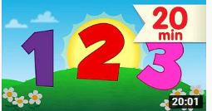
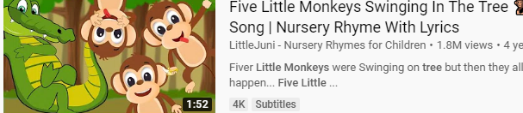
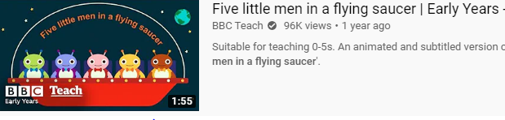
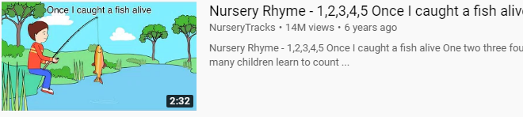
- Counting, using food eg raisins, objects eg duplo bricks. Write down a number and then count that many objects out. This develops number concept, rather than just recognising the numeral.
- Adding 1 more and 1 less to any given numbers up to 20
- Practice forming numbers
- Fill a bucket/washing up bowl full of water and find some vessels, cups, bowls, empty plastic bottles, practice pouring, explore capacity; full, empty, half full.

- Playdough
– children can develop their maths skills. Make long and short sausages, emphasis the words long and short.
- Make circles, triangles and squares with the playdough, see if children can name/ point to shapes on your request.
- Children could explore fractions by cutting pretend cakes/biscuits into halves and quarters.

- Phonics
- Sing the alphabet, we use this one at school
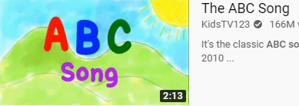
- Write the alphabet out and point to the letters, practice forming the letters.
- You tube phonics song 2
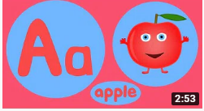
- Collect some household objects; cup, book, sock, pen, ect see if children can name/point to the initial letters sound of the words, you could write them down to support.
- Practice CVC (consonant, vowel, consonant) words, spelling and reading them:
Cat, pat, bat, pan, fan, sun, bun.

- Stories
- The barefoot stories are a favourite in Wrens Class they are available on you tube.
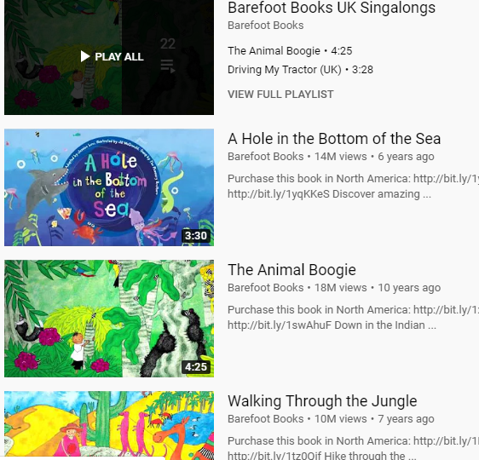
- The Gruffalo, the 3 little pigs and We’re going on a Bear Hunt are also ones we have been learning.
- Make some of the characters from the stories using junk modelling. Try retelling and “acting out” the stories

- Play – We all know how important this is for your child’s development. Spending time playing with your child is the best way to help their development!

