Dear Parents and Carers,
I hope you are all keeping well and staying safe during this time.
Below are some ideas for learning activities that you can do with your children at home related to what they have been doing this term. Please don’t feel that you have to complete every activity, these are just ideas to keep their minds active and some fun activities for you to do together - choose the activities that suit your child and your family best.
If you would like, please do send me some pictures of your home learning, I would love to see them.
Above all, enjoy this time together and have fun!
All the best,
Miss Beaven and Bramblings Team.
Phonics
- Listen to our phonics songs
  - https://www.youtube.com/watch?v=ffeZXPtTGC4 (Phonics song 2)
  - https://www.youtube.com/watch?v=1Qpn2839Kro (Jolly Phonics)
  - https://www.youtube.com/watch?v=XLSci30haL8 (ABC Song)
- Alphablocks is also great for video based learning
  - https://www.youtube.com/watch?v=w9zLaORHG1U
- Bug Club reading – log on to Bug Club and access the allocated books for their reading level and other books they may enjoy.
- Go for a phonics hunt around the house, the garden or on a walk to spot things beginning with each letter of the alphabet (see sheet below).
- Make some play dough and then practice forming letters with the dough (see recipe below)
- Practice CVC (consonant, vowel, consonant) words, recognising the letters, blending them together to read them and write them. E.g. cat, hen, pat, van, bun, sit (see sheet for more examples).
English
- Practice writing their name/matching letters of name/overwriting name
- Watch the stories we have been doing for our Theme ‘Out and About’
  - https://www.youtube.com/watch?v=s8sUPpPc8Ws (Gruffalo)
  - https://www.youtube.com/watch?v=0gyI6ykDwds (We’re Going on a Bear Hunt)
- Can they retell and act out the stories?
- Can they make their own sensory story? E.g. setting up a bear hunt in your house/garden
- Can they draw the characters/make characters from play dough?
- Can they write/say any key words from the story?
- Other great stories can be found on Barefoot Books
  - https://www.youtube.com/user/barefootbooks
Maths
Number
- Listen to our number songs
  - https://www.youtube.com/watch?v=TdDypyS_5zE (10 in the Bed)
  - https://www.youtube.com/watch?v=x_I2ysM0w0g (5 Little Firemen)
  - https://www.youtube.com/watch?v=D0Ajq682yrA (Count 1-20)
- Go for a number hunt to see which numbers you can spot out and about, can they recognise numerals on houses, on signs? Can they write down the numbers as they see them?
- Practice forming numbers with play dough – what numbers can they make?
Fractions
- Fraction fruit – encouraging children to watch you cutting fruit into halves and quarters and support them to ask for their fruit using these terms
- Can they match the halves and quarters of fruit together
- Use play dough to make pizza and cut this into halves and quarters. Count the different toppings you add!
Measurement
- Explore capacity using a washing up bowl filled with water and some empty vessels (cups, jugs, empty bottles). Practice pouring and using language full, half-full, empty.
- Make towers using Lego/Duplo, cushions, books, which is taller which is shorter?
- Measure everybody in the house against a wall! Who is the tallest, who is the shortest?
- Can they find objects around the house that are heavy? Objects that are light?
Theme (Out & About)
- Identifying the weather outside each day and keeping a record of this using sheet below. You could listen to our weather song before doing this!
  - https://www.youtube.com/watch?v=rD6FRDd9Hew
- Look at different types of transport that you might see out and about with the help of Journey Home from Grandpas Story
  - https://www.youtube.com/watch?v=wKcrsv_t8Ko
- Can they be supported to make their own ‘yellow car’ or ‘orange truck’ using instructions below?
Cooking
- Make some Gruffalo Cupcakes together using the recipe below.
- Can they represent a scene from Bear Hunt using cooking/baking e.g. thick oozy mud or swirling whirling snowstorm.
Staying Active
- Taking part in PE with Joe Wicks each morning https://www.youtube.com/playlist?list=PLyCLoPd4VxBvQafyve889qVcPxYEjdSTl
- Trying some Bear Hunt Yoga (and other yoga adventures) https://www.youtube.com/watch?v=KAT5NiWHFIU

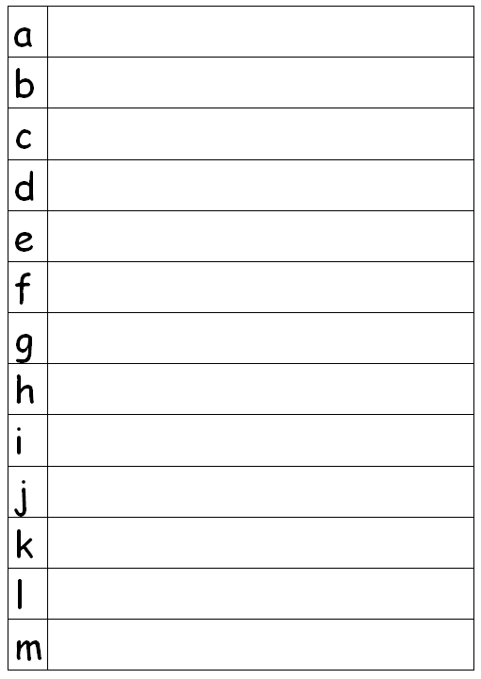
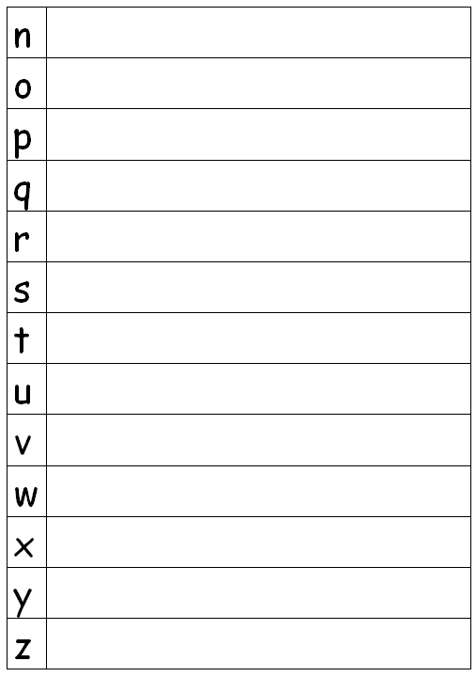
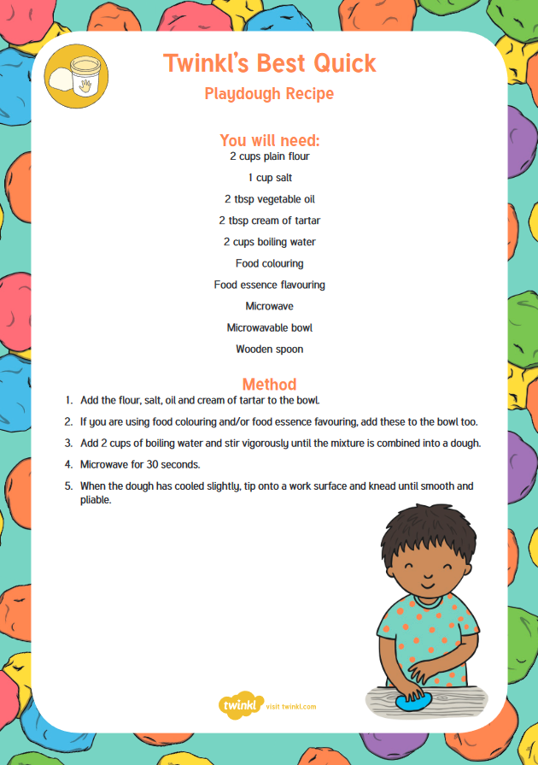
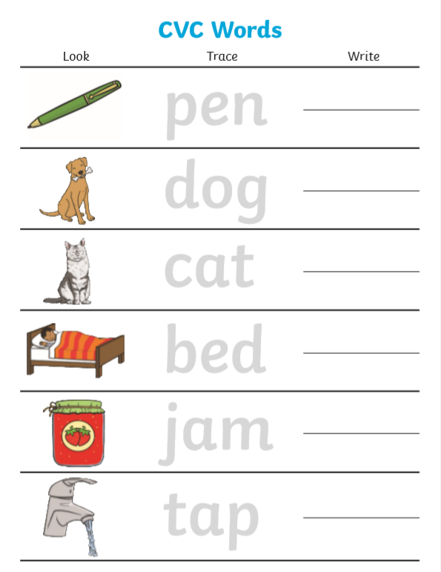
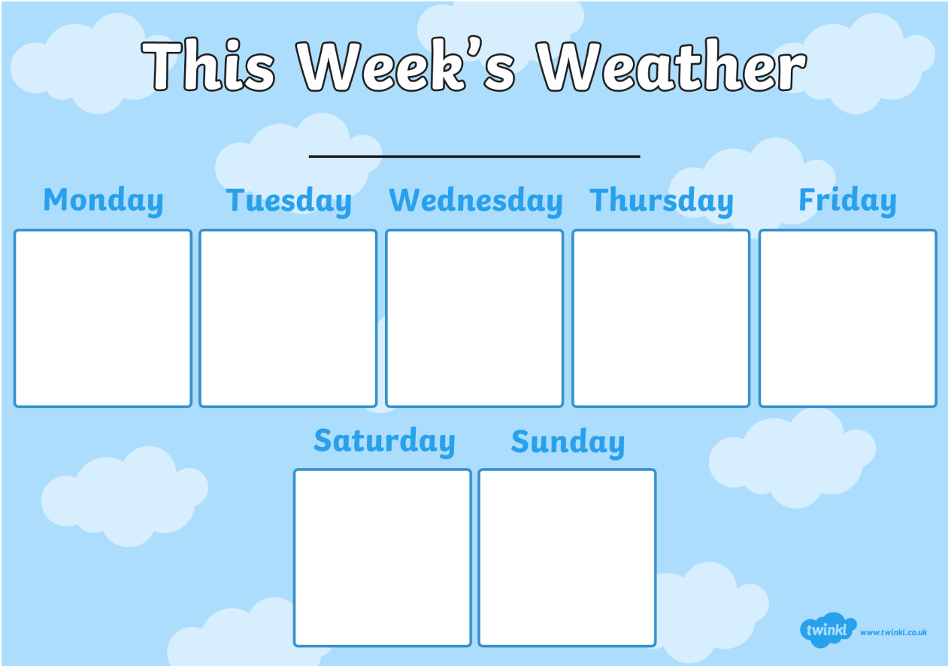
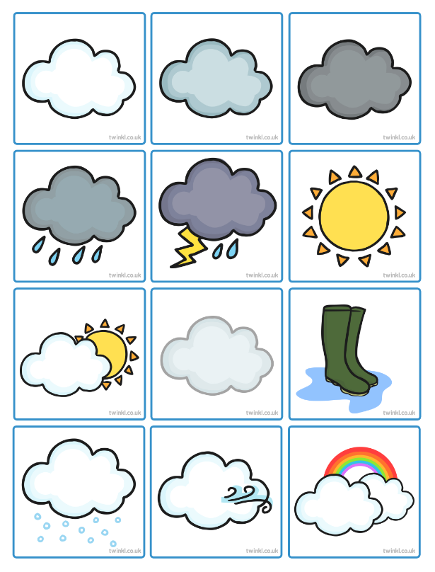

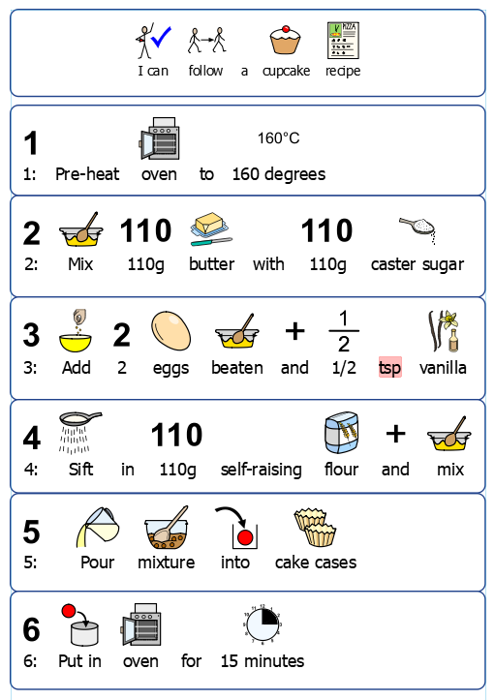
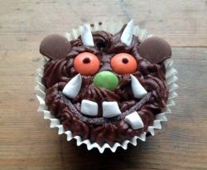
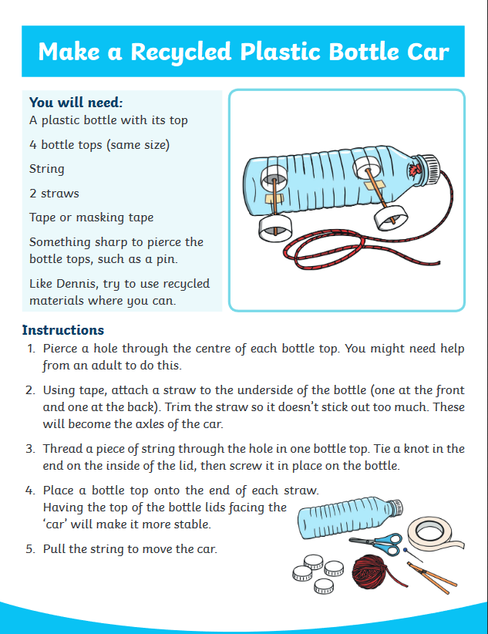
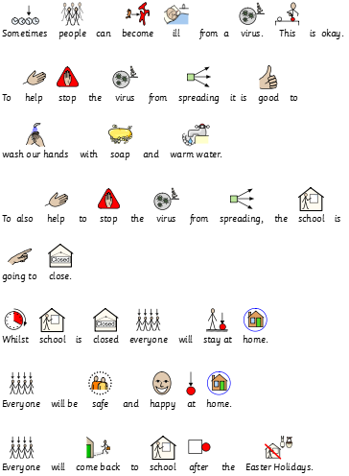
School Closure Social Story

