Finches - home learning ideas.
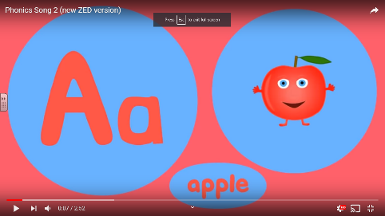
Phonics
Sing along to the song. The children enjoy singing and signing along at school. Let’s see if they can remember! https://www.youtube.com/watch?v=jPVbJ-IaHIw

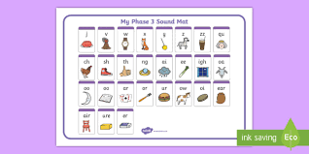
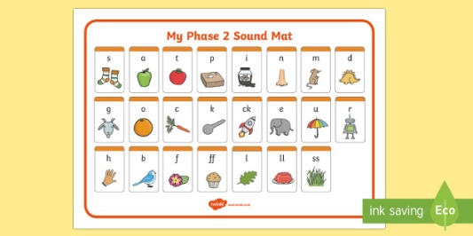
Practise sounding out the phase 2 or 3 sounds (dependent on child).

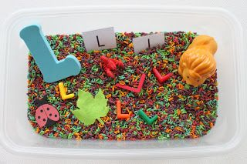

Letter sensory tray

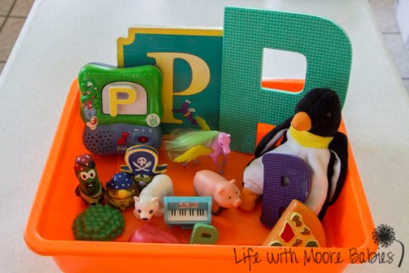
Gather a range of house hold objects that begin with a particular letter. Repeat the sound before saying the word e.g. p… p…pen. Encourage them to explore the different objects with their hands. You could also use YouTube to find sounds that begin with a particular letter e.g. pop!

Practise sounding out and blending words. There are lots of great resources of Twinkl. This booklet may be quite useful. https://content.twinkl.co.uk/resource/e0/3c/t-l-527053-cvc-word-activity-booklet-_ver_9.pdf?__token__=exp=1585316021~acl=%2Fresource%2Fe0%2F3c%2Ft-l-527053-cvc-word-activity-booklet-_ver_9.pdf%2A~hmac=bac303f80915b11b6645f532e1598bd2d1f0f2bc23cd8afd9296a0de16cbce2d
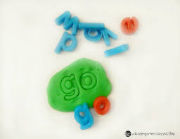
Create words by stamping letters into playdough or paint to make it more creative! Use pictures of objects instead of saying the words to make it a little trickier.

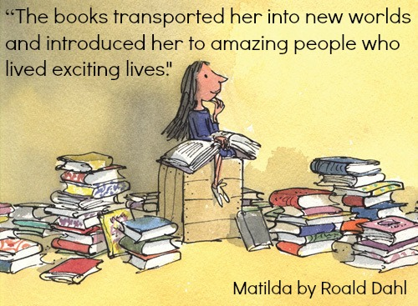
Reading
Continue to read as much as possible.
Ask them to choose a book they would like you to read to them. Encourage them to look and or point at the pictures, turn the pages and repeat key vocabulary, where applicable.
Listen to them read. I have allocated books for each child on Bug Club. Encourage them to use their phonics knowledge to sound out words they don’t know.
Try to read a range of fiction and non-fiction texts if possible.

Maths
Songs to develop counting skills. Super Simple Songs and The Singing Walrus on YouTube have a range of songs which may be useful to help develop understanding of mathematical concepts.

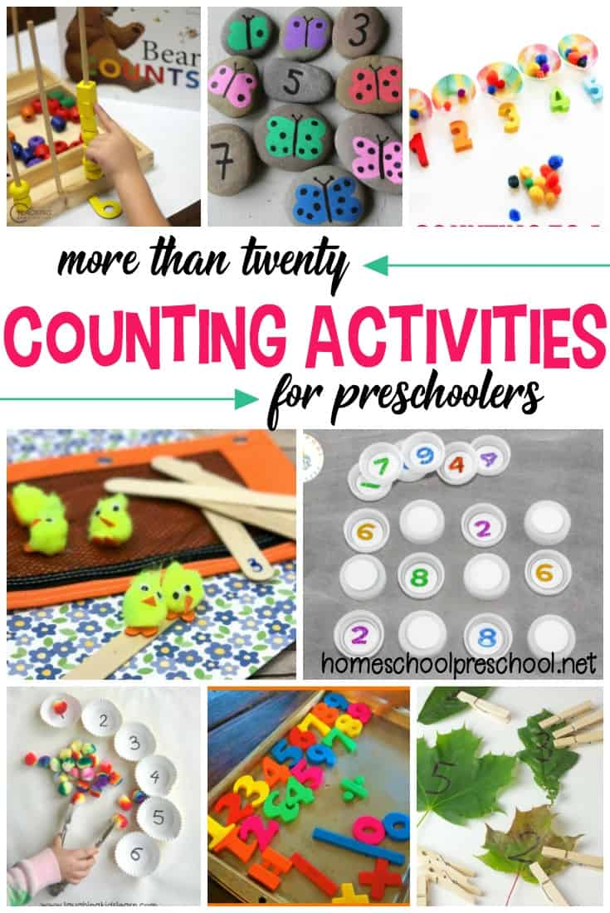
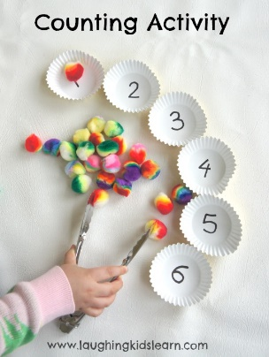
Counting activities using a rage of objects. Pinterest have some lovely and creative ideas. There are also lots of counting activities available on Twinkl.

Use tongs/tweezers etc to help develop fine motor skills.

Explore concepts such as more and less, big and small, long and short using objects found around the house. Repeat the key vocabulary as they explore.

Addition and Subtraction
Use a hands on approach to practise addition and subtraction. Use objects found around the house to practise addition and subtraction. Encourage them to write out the calculation as they do it. We have used an ‘addition machine’ in class before using an old show box and toilet rolls, which they really enjoyed this.
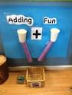

Number formation
Twinkl have some great resources to help children practise their number formation.
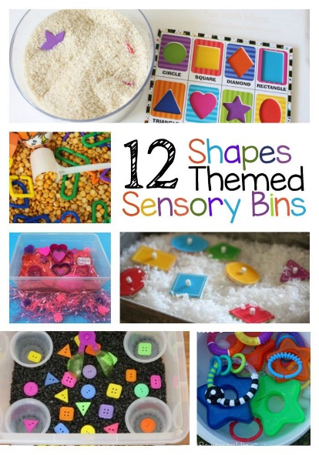
Sensory trays

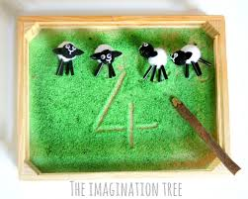
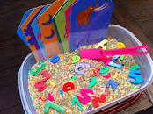
Interactive maths games
https://www.twinkl.co.uk/resources/games-twinkl-go/ks1-games-twinkl-go/maths-ks1-games-twinkl-go

English
The Gruffalo, The Snail and The Whale, The Stick Man, The Tiger Who Came to Tea, Percy the Park Keeper, Goldilocks and the Three Bears and The Three Little Pigs are all stories we have enjoyed this year. Watch and listen to the stories on YouTube. Find objects for different parts of the story to create a sensory aspect: sound, touch, smell, taste.
The Gruffalo example – use a brush for the prickles on his back.
Percy the Park Keeper example – use leaves and twigs.
The Three Little Pigs example – use twinkl to download wold and pig masks to decorate. Blow up a ballon and let it go for the “huff and puff” part of the story.
Goldilocks and the Three bears example – make porridge.
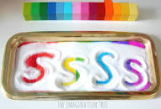
Letter formation
Twinkl have some great resources to help children develop their letter formation.
Sensory tray letter formation using salt.

Writing sentences
Use images taken from the stories on YouTube/Google to write sentences about what they can see in the picture.

Over and under writing
Trace the letters to help develop letter formation.

Write words out underneath.

Playdough disco
Follow along and use playdough to develop fine motor skills
https://www.youtube.com/watch?v=1JaF0mjG4e8
https://www.youtube.com/watch?v=DrBsNhwxzgc
https://www.youtube.com/watch?v=ocFu_ZFgQi4
Mindfulness activities and brain break activities
We use this often in school and the children really enjoy it https://www.youtube.com/user/CosmicKidsYoga
Arts and Craft
Twinkl have a wide range of arts and craft ideas.

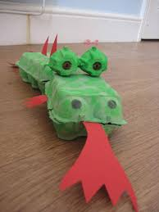
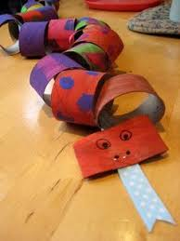
Junk Modelling
Create South American animals

