Starlings Home Learning Ideas

Spring

Rainbow  Can you paint, colour, draw or make a rainbow to put up in your window?  Can you see any in other people’s windows?  Ext : Can you write a message to any key workers who live near you and post it in your window? | Spring Walk  Go on a spring walk in your garden or close to your home. What can you see, hear, feel and smell?  Can you add any of your own ideas to the list?  Ext : Pick a flower from your garden and see if you can do a detailed drawing  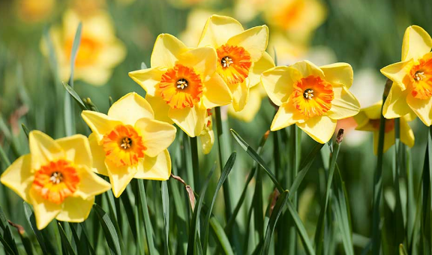 | Colour Matching  In your house or garden can you find something for each colour of the rainbow?  Ext : Can you sort objects into groups of colours? | Easter Egg  Can you design your own Easter Egg? You could use pens, paints or play dough?  Ext: Can you think of a name for your Easter egg and design packaging for it?
Numbers  How many numbers can you find in your house?  Can you match them to the number cards?  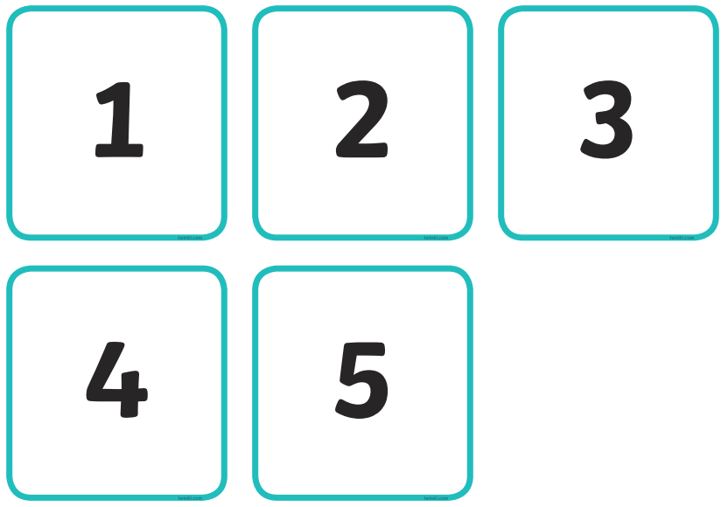  Can you make the numbers using for example pasta or Lego?  Extension: Can you find the numbers to 20 or higher? | Capacity  Enjoy water play. Possibly add food colouring or glitter to the water. Can you use different size containers? Can you fill them so they are full or half full? Can you fill 5 containers (pick different numbers)?  Ext: Can you read the scale on the side of a measuring jug?  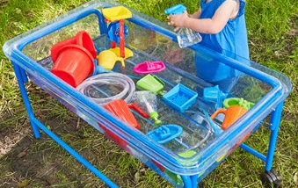 | Songs and rhymes  Sing songs and rhymes linked to spring e.g  Round and round the garden like a teddy bear, one step, 2 steps, tickle under there.  See words for more rhymes and songs further down the sheet  Extension: write a spring poem. | Dance  In school we enjoy dancing to Zorba the Greek. Can you find songs and dances from other countries to dance along to?

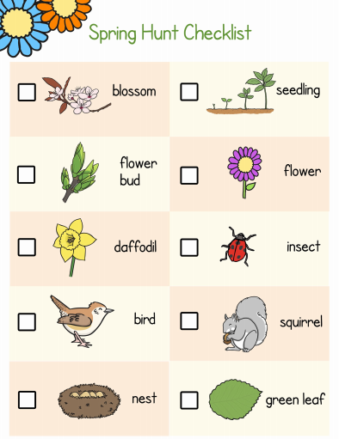
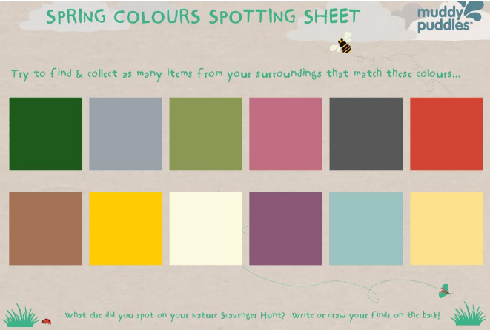

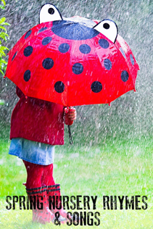
FIVE LITTLE SPECKLED FROGS

5 Little Speckled Frogs,
Sat on a little log,
Eating some most delicious grubs,
YUM YUM!
One jumped into the pool,
Where it was nice and cool
And now there are 1, 2, 3, 4 green speckled frogs!
4 Little Speckled Frogs,
Sat on a little log,
Eating some most delicious grubs,
YUM YUM!
One jumped into the pool,
Where it was nice and cool
And now there are 1, 2, 3 green speckled frogs!
3 Little Speckled Frogs,
Sat on a little log,
Eating some most delicious grubs,
YUM YUM!
One jumped into the pool,
Where it was nice and cool
And now there are 1, 2 green speckled frogs!
2 Little Speckled Frogs,
Sat on a little log,
Eating some most delicious grubs,
YUM YUM!
One jumped into the pool,
Where it was nice and cool
And now there is only 1 green speckled frogs!
1 Little Speckled Frogs,
Sat on a little log,
Eating some most delicious grubs,
YUM YUM!
One jumped into the pool,
Where it was nice and cool
And now there are NO green speckled frogs!

5 LITTLE DUCKS
5 Little ducks went swimming one day
Over the hills and far away
Mamma Duck said
“Quack Quack Quack Quack!”
And only 4 little ducks came swimming back.
4 Little ducks went swimming one day
Over the hills and far away
Mamma Duck said
“Quack Quack Quack Quack!”
And only 3 little ducks came swimming back.
3 Little ducks went swimming one day
Over the hills and far away
Mamma Duck said
“Quack Quack Quack Quack!”
And only 2 little ducks came swimming back.
2 Little ducks went swimming one day
Over the hills and far away
Mamma Duck said
“Quack Quack Quack Quack!”
And only 1 little duck came swimming back.
1 Little duck went swimming one day
Over the hills and far away
Mamma Duck said
“Quack Quack, Quack Quack!”
And no little ducks came swimming back.

IT’S RAINING, IT’S POURING
It’s raining, it’s pouring,
The old man is snoring!
He went to bed,
And bumped his head!
And couldn’t get up in the morning!

DAFFODILS
One little daffodil had nothing much to do,
Out popped another one, then there were two.
Two little daffodils were smiling at a bee,
Out popped another one, then there were three.
Three little daffodils were growing by the door,
Out popped another one, then there were four.
Four little daffodils were glad to be alive,
Out popped another one, then there were five.
Five little daffodils were wearing golden crowns,
They danced in the breeze in green satin gowns

