Phonics
Phonic games/videos
- Log on to www.spellingframe.co.uk - Access games/tests to develop recognition and spelling of sound.
- http://www.galacticphonics.com/ Click on to different sounds and access the games
- https://www.phonicsbloom.com/
- https://new.phonicsplay.co.uk/
- https://www.youtube.com/user/breakthruchris - Videos on how to pronounce different sounds
Activities:
- Choose a letter sound and think of as many words that start with that sound.
- Choose a letter sound and find items in the house/garden that start with that sound.
- Choose 5 letters and make as many words as you can within 2 minutes.
- Focus on a sound and see if you can find it in a book. How many times does it appear on a page? Sound out each word and then spell it.
- Put letters in alphabetical order. Then choose 6 words and put in alphabetical order.
- Practice letter formation- write in sand, salt, rice
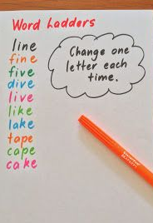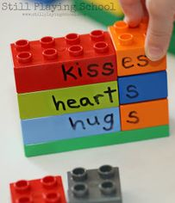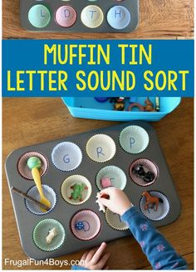

English
Reading
- https://www.activelearnprimary.co.uk/login?c=0 Log on and access bug club e-books. Click on the bugs to answer the questions.
- Choose a book of your choice to share with someone. Can you quiz them to see if they were listening?
- Read about a topic of interest on the computer.
- Read everyday texts such as packets, instructions, bottles, tins
- https://www.14stories14days.co.uk
- https://usborne.com/play-and-learn-at-home/
- https://www.oxfordowl.co.uk/
- Listen to audio stories on youtube.
Activity ideas
- Dictionary work- Scavenger hunt
- Word association- Say a word and next person to think of something that links to that word.
- Categories game- Choose a category and come up with something for every letter e.g. animals- ant, bear, cat, dog, elephant etc
- Write a story- Has it got a beginning, middle and end?
- Choose a favourite story and change aspects of it e.g. the ending, characters
- Write instructions on how make something?
- Write a book review about your favourite book.
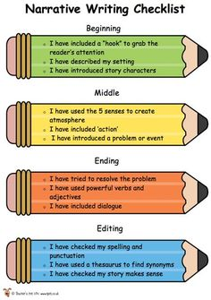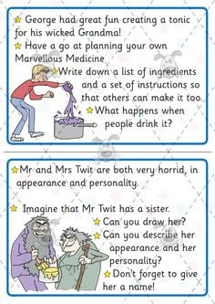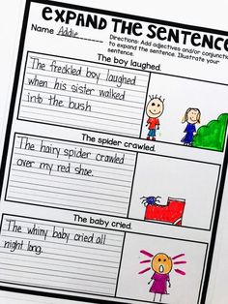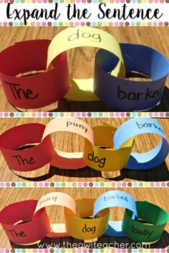

Maths
Maths games online
- www.Mathsframe.co.uk - number, money, time games
- https://www.doorwayonline.org.uk/ - Money and time games
- www.themathsfactor.com
- https://www.topmarks.co.uk
- https://www.coolmathgames.com/
Maths Activities
- Money- name and order coins. Make different amounts
- Give each snack/drink/meal a price and each time you eat you have to pay for the item. Can you work out the change?
- Give yourself a challenge. How many can you do in a minute? How long does it take you to do 20 star jumps? Can you beat your time?
- Read a bus timetable, tell the time throughout the day.
- Roll 2 or 3 dice. Add/subtract/divide/multiple/double/halve numbers. Then using the 100 square track how many numbers you can make.
- Place value- Choose 3 or 4 numbers. How many numbers can you make? Can you order them? What’s the highest/lowest value? In 4302 what does the 3 mean e.g. 300.
