St John’s Safeguarding Team
Mrs West-Gaul  Headteacher | Mrs Monks  Deputy Head and SENCO | Mrs Stearn  Key Stage Two Lead
Mrs Stone  EYFSand Key Stage One Lead | Mrs Dando  Nursery Manager

St John’s Wellbeing Team
 |  | 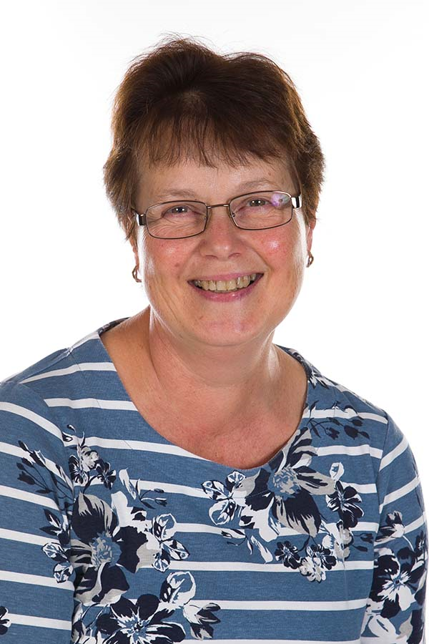
Mrs Stone  Wellbeing Lead | THRIVE Lead | Mrs Emery  Forest School Lead
 |  | 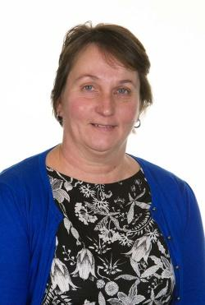
Miss Withers  Teacher | Mrs Pughe  Theraplay | Mrs Toulson  Wellbeing Mentor

