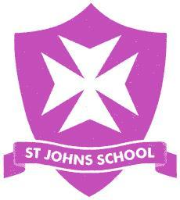
Year 1 Term 1 - Spellings

This term your child will be expected to learn the following spellings each week. These spellings are year 1 tricky words which are covered in phonics lessons each week. These will be informally assessed throughout the week. The aim is for your child to be able to both read and spell these before the end of the year.
Ways to help your child learn tricky words:
- Read the tricky word to your child, then read it together. Say the word again, sound by sound. Identify the tricky bit. For example, the tricky part in ‘we’ is that the ‘e’ is making the /ee/ sound rather than /e/.
- Tracing, copying and writing of tricky words in various media will increase recall i.e. in the air, with a wet paint brush, chalk, shaving cream, playdough etc.
- Play games - Bingo, online games (phonicsbloom and phonicsplay), play ‘Mix and Fix (make the tricky word with magnetic letters or letter tiles, check it, then mix the letters up and fix them up again).
- Spot the tricky words in books you are reading together.

wb: 13/9  he  she | wb: 20/9  we  me
wb: 27/9  be  you | wb: 14/10  are  her
wb: 11/10  was  all | wb: 18/10  they  my

